
SARATOGA BATTLE CHAPTER, SAR
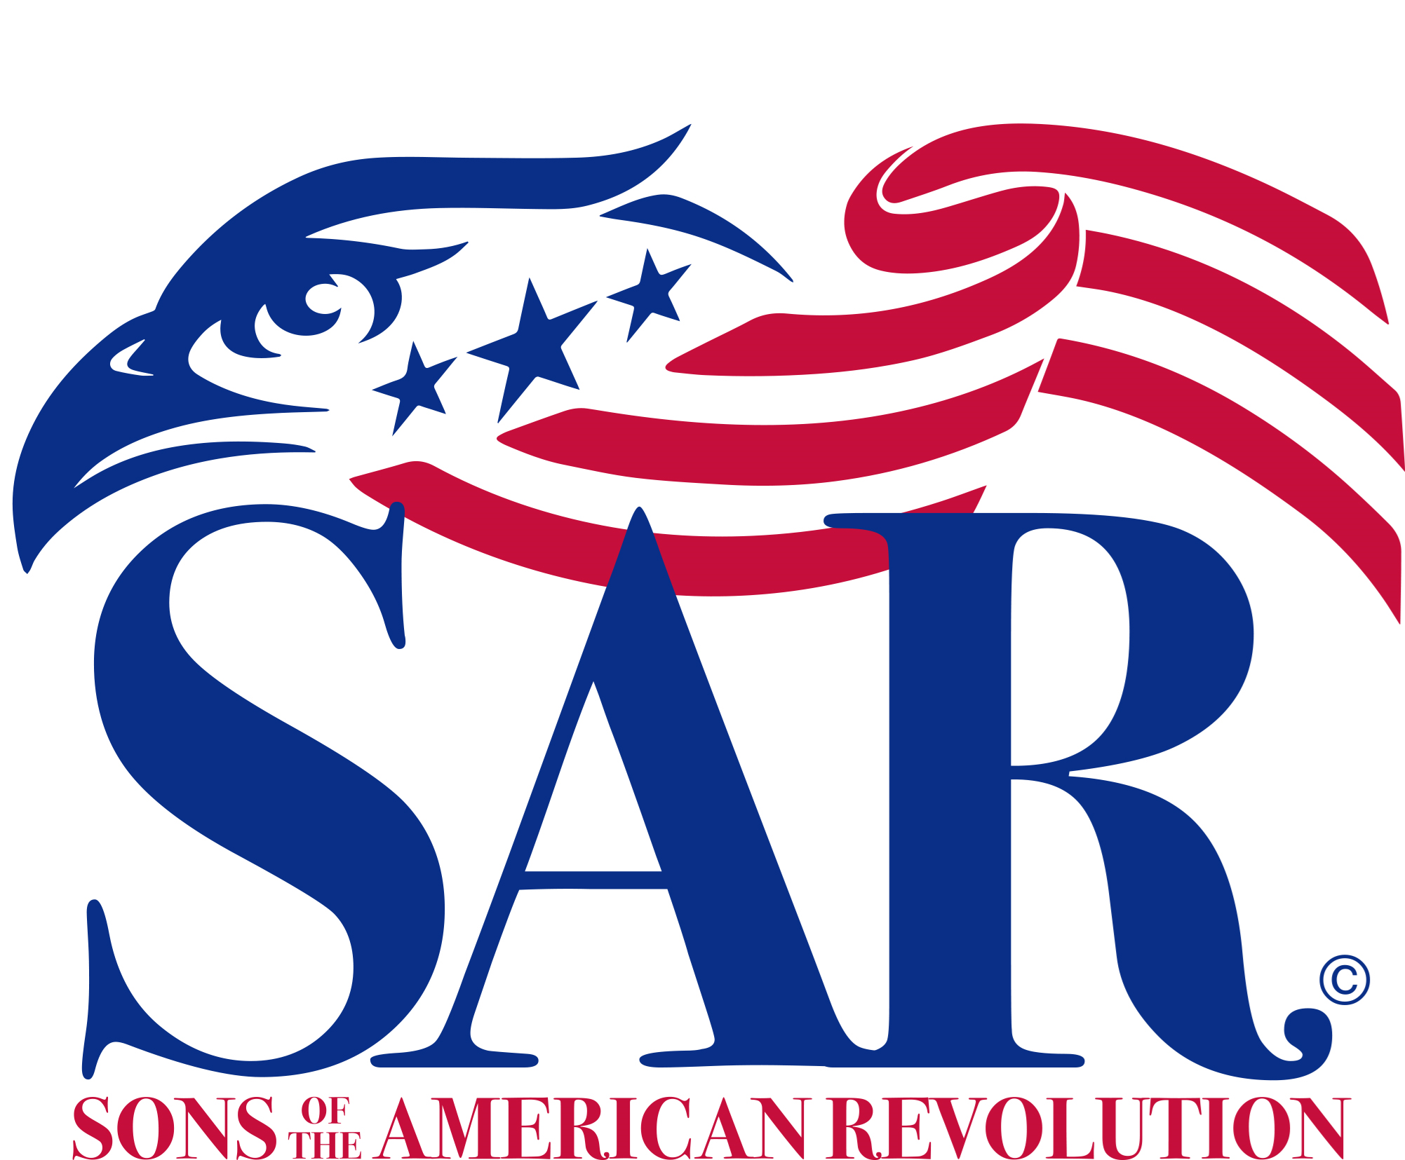
ANNUAL MEETING
And
WASHINGTON’S BIRTHDAY LUNCHEON

Saturday, February 19, 2022
The Longfellows Hotel & Restaurant
500 Union Avenue, Saratoga Springs, NY 12866 (518) 587-0108
Directions:
From North and South: Take I-87 (Adirondack Northway) to exit 14. Follow NY-9P S/Union Ave in Saratoga Springs to Longfellows. From East and West: Take I-90 (New York Thruway) exit 24 to I-87, then north to exit 14 and follow NY-9P, S/Union Ave, to Longfellows.

Fellowship 11:30 to Noon

Luncheon Served at 12:00 pm

Cost per person is $32.00
(RSVP by February 12th)

First Course – Fresh Garden Salad
Entrees (choose one per person):
- Herb Marinated Sliced Steak w/ Deep Demi Glaze Sauce
- Lemon Chicken Francais, Egg Batter Dipped and Pan Seared
w/ Light Lemon Garlic Wine Sauce

Dessert - Chocolate Mousse w/ Whipped Cream Topping

Business Meeting at 1 pm
w/ Election of Officers

Mail to: David L. Flint, Treasurer Telephone: (518) 391-0881
Saratoga Battle Chapter, NSSAR Email: treasurer@saratogabattle-sar.org
89 Calvin Cole Rd
Stephentown NY 12169-1800
_________________________________________________________________________________________
Reservation Form: (Please, no email or phone reservations.)

Name: ___________________________________ Lunch Choice: ___________________________________
Name: ___________________________________ Lunch Choice: ___________________________________
Total Lunches = $______ + Patriot Ancestor Listing Donation $________ = $________
Patriot Ancestor(s): _________________________________________________________________________
_________________________________________________________________________
_________________________________________________________________________
_________________________________________________________________________

