SARATOGA BATTLE CHAPTER, SAR

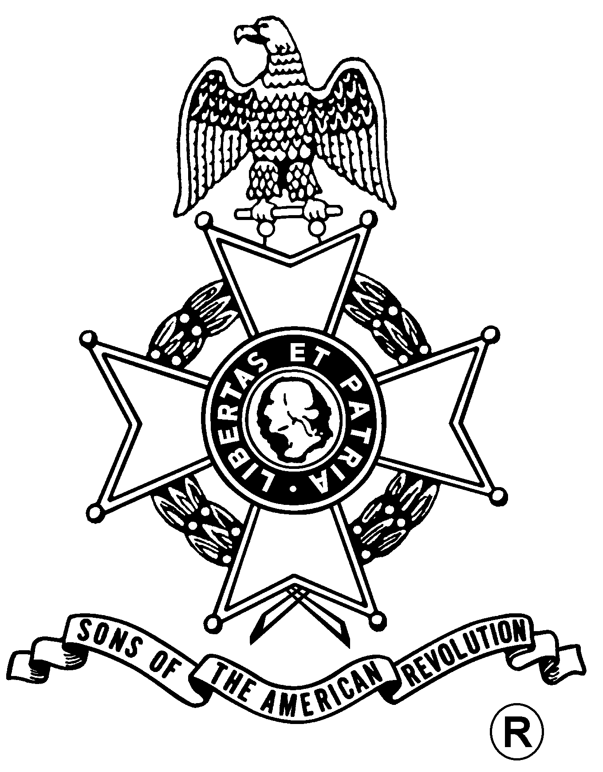
ANNUAL MEETING
And
WASHINGTON’S BIRTHDAY LUNCHEON

Saturday, February 22, 2020
Century House
997 New Loudon Road (Rte. 9), Latham, NY 12110 (518) 785-0834
Directions:
From North and South: Take I-87 (Adirondack Northway) to exit 7. Follow signs to Route 9 Latham. Take Route 9 North. Restaurant is one mile on right. From East and West: Take I-90 (New York Thruway) exit 24 to I-87 (Adirondack Northway) exit 7. Follow signs for Route 9 North. Century House is one mile on right.

Fellowship 11:30 to Noon

Luncheon Served at 12:00 pm

Cost per person is $42.00
(RSVP by February 18th)

First Course - Century House Salad with Balsamic Vinaigrette
Entrees (choose one per person):
- Bistro Steak with Herb Butter, Roasted Skinny Potatoes Filet Citrus
- Chicken Oscar century Roasted Asparagus and New Potatoes, Hollandaise
(Chicken Cutlet, Lobster Meat, Roasted Asparagus Lemon Sauce)
Dessert - Century House Signature Chocolate Mousse

Business Meeting at 1 pm
Awards
Speaker – Eric Schnitzer on his new book
Campaign to Saratoga-1777

Mail to: David L. Flint, Treasurer Telephone: (518) 733-5871
Saratoga Battle Chapter, NSSAR Email: treasurer@saratogabattle-sar.org
89 Calvin Cole Rd
Stephentown NY 12169-1800
_________________________________________________________________________________________
Reservation Form: (Please, no email or phone reservations.)

Name: ___________________________________ Lunch Choice: ___________________________________
Name: ___________________________________ Lunch Choice: ___________________________________
Total Lunches = $______ + Patriot Ancestor Listing Donation $________ = $________
Patriot Ancestor(s): _________________________________________________________________________
_________________________________________________________________________
_________________________________________________________________________
_________________________________________________________________________

