SARATOGA BATTLE CHAPTER, SAR

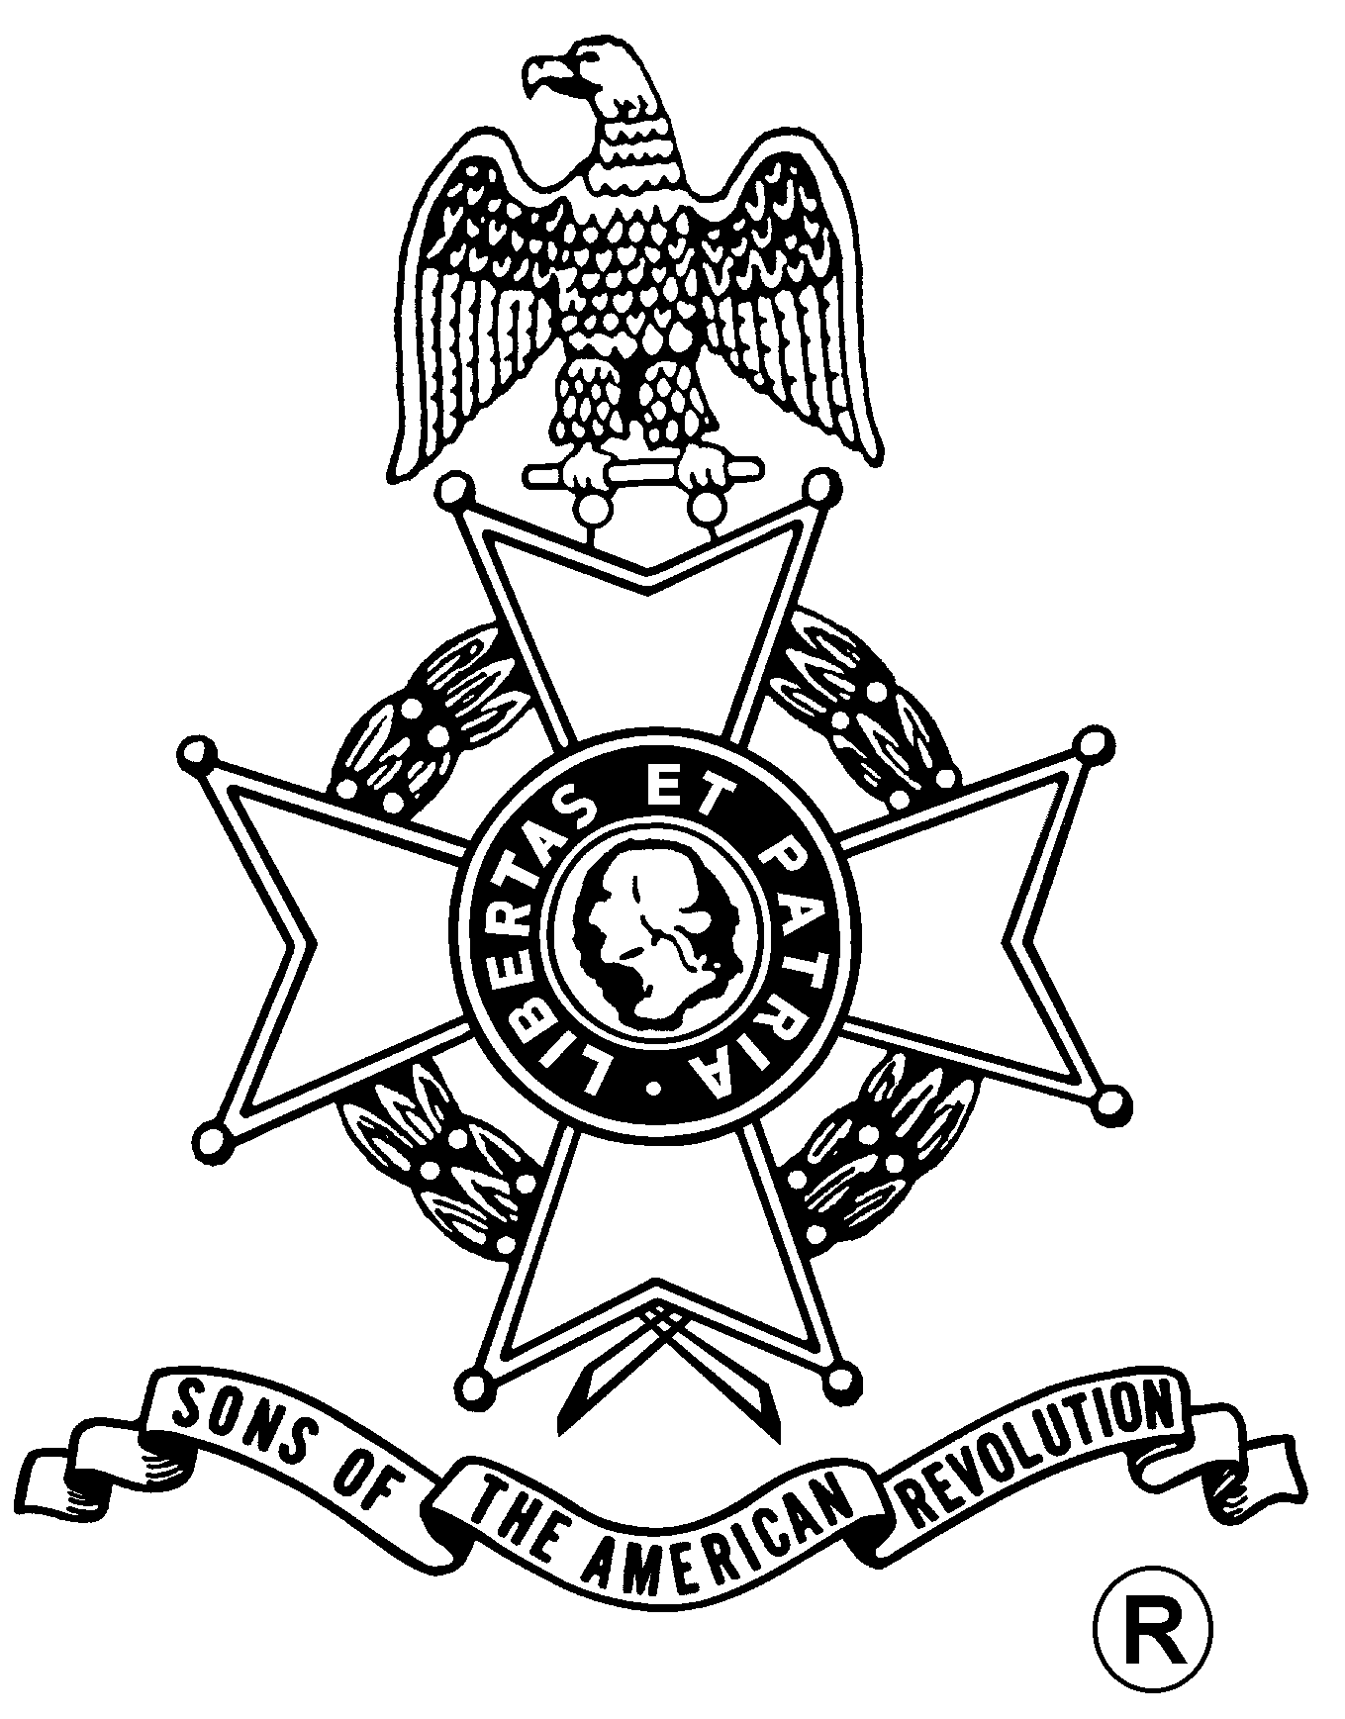
ANNUAL MEETING
And
WASHINGTON’S BIRTHDAY DINNER

Saturday, February 23, 2019
Century House
997 New Loudon Road (Rte. 9), Latham, NY 12110 (518) 785-0931
Directions:
From North and South: Take I-87 (Adirondack Northway) to exit 7. Follow signs to Route 9 Latham. Take Route 9 North. Restaurant is one mile on right. From East and West: Take I-90 (New York Thruway) exit 24 to I-87 (Adirondack Northway) exit 7. Follow signs for Route 9 North. Century House is one mile on right.

Fellowship 12:00 Noon

Meeting Begins 12:30pm

Luncheon Served at 1:00 pm

Cost per person is $35.00

RSVP by February 18th
Entrée choices (choose one per person):
Chicken Oscar (chicken breast in a hollandaise sauce)
Truffle Sirloin (steak with mushroom sauce)

[both entrees can be prepared gluten free upon request]

All meals will include:
Century Salad
Rolls and butter
Chef’s Choice vegetable and starch
Mug Trifle for dessert

Mail to: David Flint, Treasurer Telephone: (518) 733-5871
Saratoga Battle Chapter, NSSAR Email: treasurer@saratogabattle-sar.org
89 Calvin Cole Rd.
Stephentown, NY 12169-1800
_________________________________________________________________________________________
Reservation Form: (Please, no email or phone reservations.)

Name: ___________________________________ Dinner Choice: ___________________________________
Name: ___________________________________ Dinner Choice: ___________________________________
Total Meals = $______ + Patriot Ancestor Listing Donation $________ = $________
Patriot Ancestor(s): _________________________________________________________________________
_________________________________________________________________________
_________________________________________________________________________
_________________________________________________________________________

