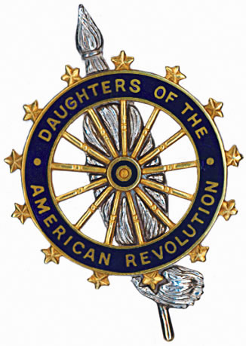

Fort Crailo Chapter, NSDAR
Invites you
To the Grave Marking Ceremony to celebrate the
Life and Revolutionary War service of

Absalom Townsend, Pvt
5th Regiment New York

Saturday
June 2, 2018 – 11 a.m.
Beverwyck Cemetery
Washington Avenue
Rensselaer, Rensselaer County, NY

Followed by a reception for attendees, hosted by the
Fort Crailo Chapter, NSDAR
immediately following the grave marking at
The Rensselaer Public Library
676 East St.
Rensselaer, NY

Please RSVP by May 12,2018
chloeboy@msn.com or 518-312-7830
Call or text

