SARATOGA BATTLE CHAPTER, SAR

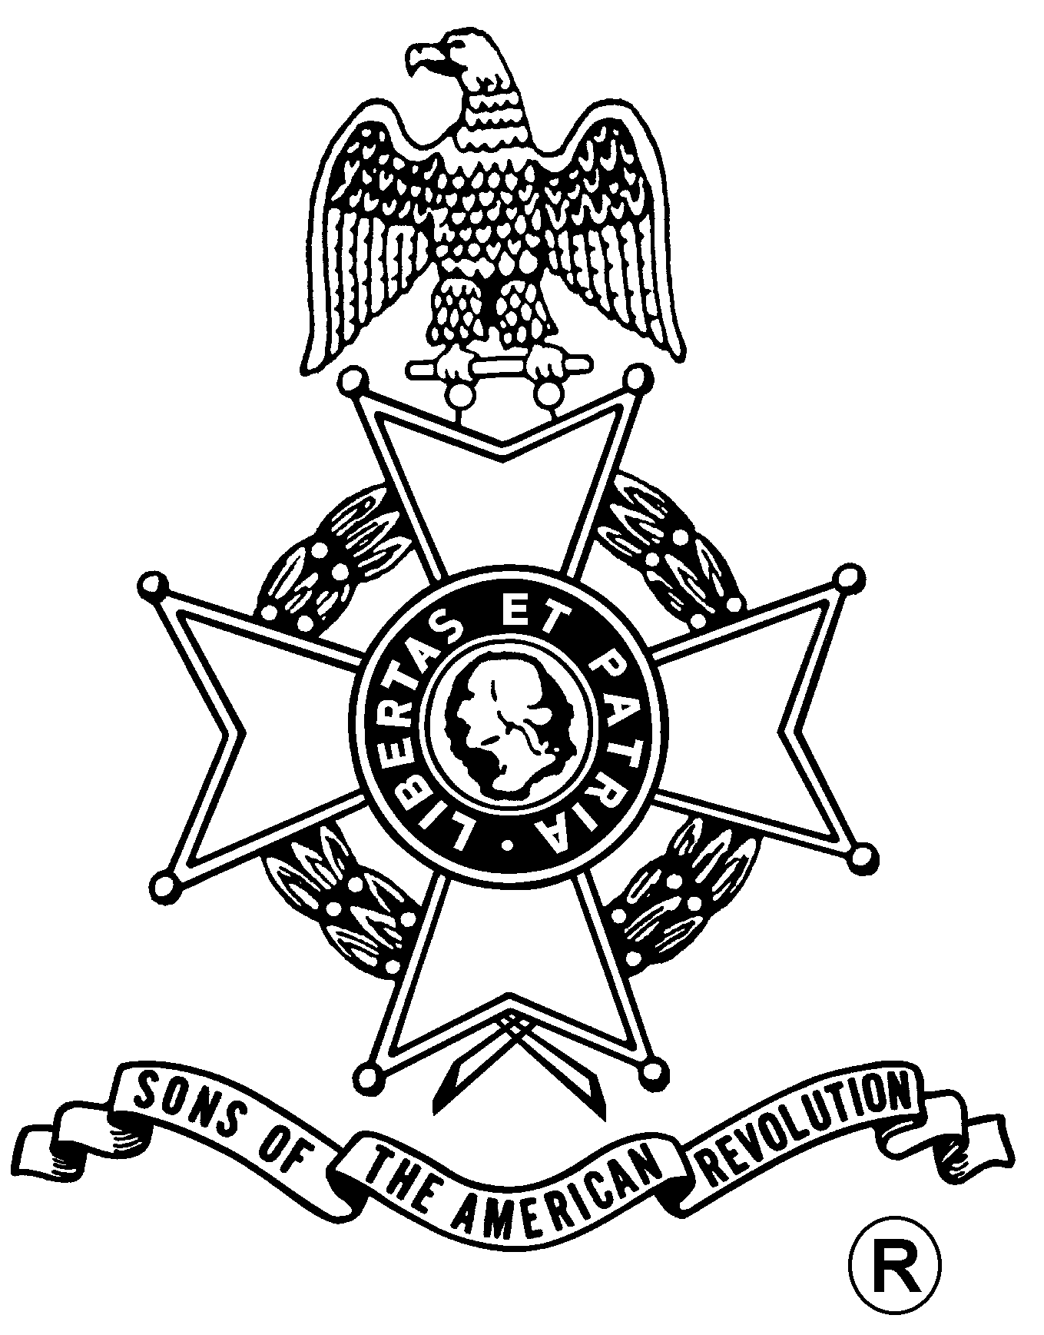
ANNUAL MEETING
And
WASHINGTON’S BIRTHDAY DINNER

Saturday, February 24, 2018
Holiday Inn Express & Suites Latham
400 Old Loudon Road (Rte. 9), Latham, NY 12110 (518) 783-6161
Directions:
From all directions: Take I-87 (Adirondack Northway) to exit 7. Follow signs to Route 9 Latham. Take Route 9 North. Make a right turn onto NY Route 9R. Hotel is almost immediately on the right.

Fellowship 11:30am, Meeting, 12:00pm

Luncheon Served at 12:30 pm

Cost per person is $35.00

RSVP by February 20th
Menu
Entrée choices (choose one per person):
Marinated Flank Steak with Oven Roasted Potatoes
or
Chicken Marsala with Mashed Potatoes
(both selections can be prepared gluten free upon request)

All meals come with House Salad, Dinner Rolls and Seasonal Vegetables
Decadent Chocolate Cake for dessert

Mail to: David Flint, Treasurer Telephone: (518) 733-5871
Saratoga Battle Chapter, NSSAR Email: treasurer@saratogabattle-sar.org
89 Calvin Cole Rd.
Stephentown, NY 12169-1800
_________________________________________________________________________________________
Reservation Form: (Please, no email or phone reservations.)

Name: ___________________________________ Dinner Choice: ___________________________________
Name: ___________________________________ Dinner Choice: ___________________________________
Total Meals = $______ + Patriot Ancestor Listing Donation $________ = $________
Patriot Ancestor(s): _________________________________________________________________________
_________________________________________________________________________
_________________________________________________________________________
_________________________________________________________________________

