SARATOGA BATTLE CHAPTER, SAR

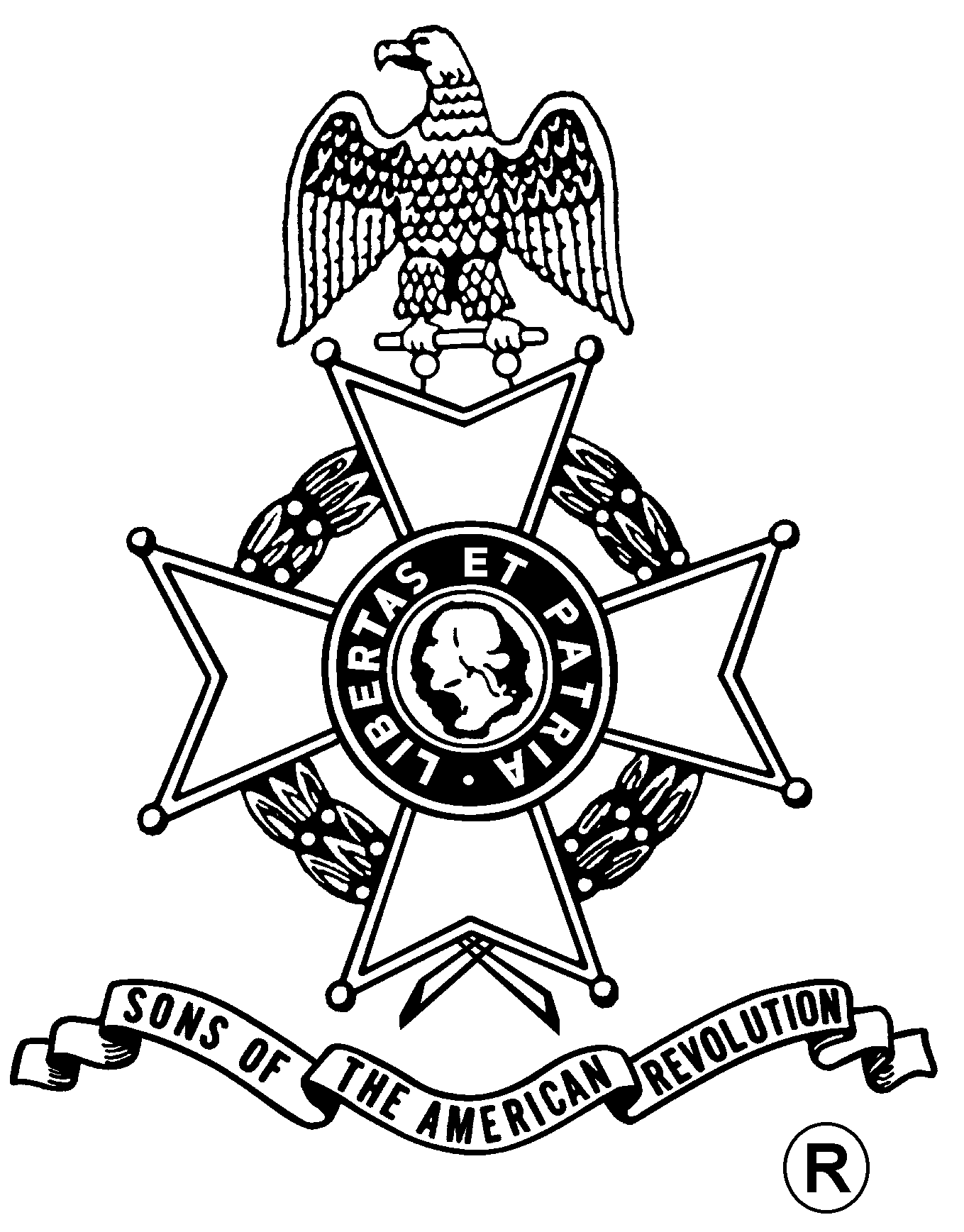
ANNUAL MEETING
And
WASHINGTON’S BIRTHDAY DINNER

Saturday, February 20, 2016
Century House
997 New Loudon Road (Rte. 9), Latham, NY 12110 (518) 785-0931
Directions:
From North and South: Take I-87 (Adirondack Northway) to exit 7. Follow signs to Route 9 Latham. Take Route 9 North. Restaurant is one mile on right. From East and West: Take I-90 (New York Thruway) exit 24 to I-87 (Adirondack Northway) exit 7. Follow signs for Route 9 North. Century House is one mile on right.

Fellowship 12:00 Noon, Meeting, 12:30pm

Luncheon Served at 1:00 pm

Guest speaker – Saratoga National Historical Park Superintendent Amy Bracewell

Cost per person is $32.00

(RSVP by February 17th)

Menu
Century House Salad with Sundried Cherry Vinaigrette
Entrees (choose one per person):
- Herb Glazed Chicken Shallot & Herb Jus
- Char-Grilled Salmon Filet Citrus Chardonnay Beurre Blanc
- Sirloin Steak Char-Grilled Center Cut, Cabernet Demi-Glace
Dessert - Century House Signature Chocolate Mousse

Mail to: Douglas M. Gallant, Treasurer Telephone: (518) 383-3217
Saratoga Battle Chapter, NSSAR Email: treasurer@saratogabattle-sar.org
45 Acorn Ave.
Clifton Park, NY 12065-5339
_________________________________________________________________________________________
Reservation Form: (Please, no email or phone reservations.)

Name: ___________________________________ Dinner Choice: ___________________________________
Name: ___________________________________ Dinner Choice: ___________________________________
Total Meals = $______ + Patriot Ancestor Listing Donation $________ = $________
Patriot Ancestor(s): _________________________________________________________________________
_________________________________________________________________________
_________________________________________________________________________
_________________________________________________________________________

