SARATOGA BATTLE CHAPTER, SAR

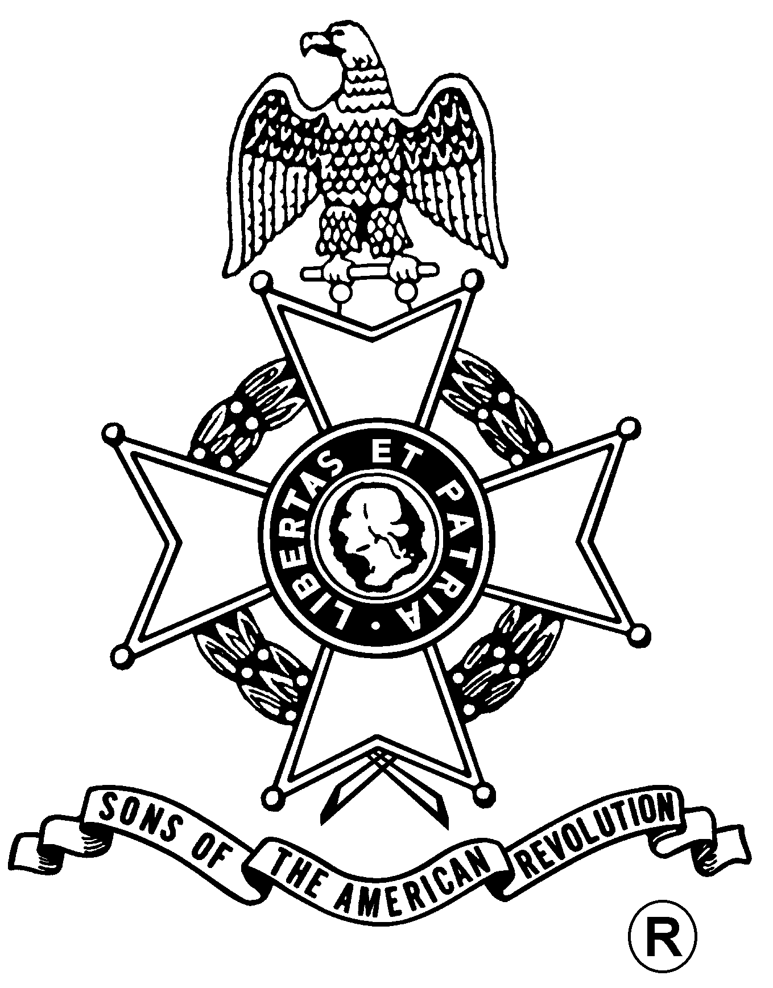
ANNUAL MEETING
And
WASHINGTON’S BIRTHDAY DINNER

Saturday, February 21, 2015
Century House
997 New Loudon Road (Rte. 9), Latham, NY 12110 (518) 785-0931
Directions:
From North and South: Take I-87 (Adirondack Northway) to exit 7. Follow signs to Route 9 Latham. Take Route 9 North. Restaurant is one mile on right. From East and West: Take I-90 (New York Thruway) exit 24 to I-87 (Adirondack Northway) exit 7. Follow signs for Route 9 North. Century House is one mile on right.

Fellowship, 5:00 pm – Dinner Served at 5:30 pm
Chicken Marsala or Grilled Filet of Salmon or
Sirloin Steak - $37.00

(RSVP by February 18th)

Century House Salad
Mixed Field Greens with Sundried Cherry Vinaigrette
Choice of
Chicken Marsala
Boneless Chicken Breasts Pan-Seared with Olive Oil, Finished
with Fresh Mushrooms in a Marsala Wine Sauce,
Grilled Filet of Salmon
In a Lemon Dill beurre blanc
Sirloin Steak
Chargrilled, center cut Sirloin Steak,
Cabernet Demi-Glace
Dessert Course
New York style Cheese Cake, with fruit puree

Business Meeting
Awards

Mail to: Douglas M. Gallant, Treasurer Telephone: (518) 383-3217
Saratoga Battle Chapter, NSSAR Email: treasurer@saratogabattle-sar.org
45 Acorn Ave.
Clifton Park, NY 12065-5339
_________________________________________________________________________________________
Reservation Form: (Please, no email or phone reservations.)

Name: ___________________________________ Dinner Choice: ___________________________________
Name: ___________________________________ Dinner Choice: ___________________________________
Total Dinners = $______ + Patriot Ancestor Listing Donation $________ = $________
Patriot Ancestor(s): _________________________________________________________________________
_________________________________________________________________________
_________________________________________________________________________
_________________________________________________________________________

