SARATOGA BATTLE CHAPTER, NSSAR

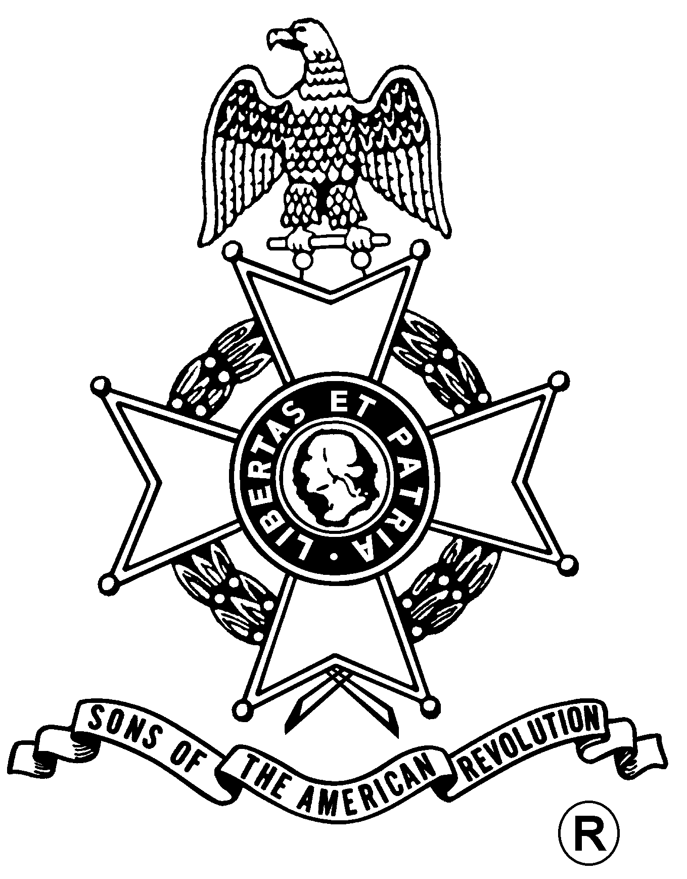
ANNUAL MEETING
And
WASHINGTON’S BIRTHDAY DINNER

Saturday, February 23, 2013
Holiday Inn
232 Broadway, Saratoga Springs, NY 12866 (518) 584-4550

Fellowship, 5:00 pm – $24.00 per Dinner, Served at 5:30 pm
(RSVP by February 19th)

Mixed Green Salad w/ House Dressing / Rolls & Butter
Choice of
Chicken Cordon Bleu, Sliced Roast Beef Tips w/ Gravy, or
Baked Scrod with Leeks, Plum Tomatoes& Olives in Lobster Broth
Baked Stuffed Potatoes & Broccoli & Cauliflower au Gratin
cheesecake with strawberries

Business Meeting
Installation of Officers

Mail to: Michael Companion, Treasurer Telephone: (518) 885-5445
Saratoga Battle Chapter, SAR Email: Mscompanion@aol.com
121 W Milton Rd.
Ballston Spa, NY 12020-2805

Reservation Form: (Please, no email or phone reservations.)

Name: ___________________________________ Dinner Choice: ___________________

Name: ___________________________________ Dinner Choice: ___________________

Total Dinners @ $24 x ___ Dinners = $______ + Patriot Ancestor Listing Donation $________ = $________

Patriot Ancestor(s): _________________________________________________________
_________________________________________________________
_________________________________________________________

