SARATOGA BATTLE CHAPTER, NSSAR

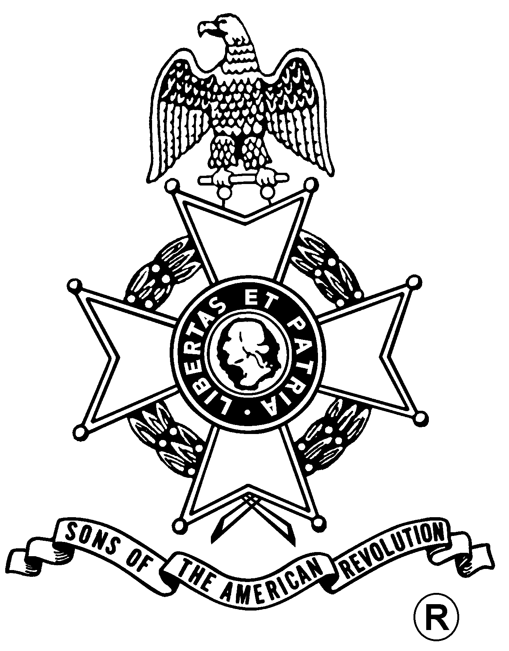
ANNUAL MEETING
And
WASHINGTON’S BIRTHDAY DINNER

Saturday, February 14, 2009
Manna’s Restaurant
17 Low Street, Ballston Spa, NY (518) 885-1195

Fellowship, 5:30 pm – $25.00 per Dinner, Served at 6:00 pm
(RSVP by February 7th)

Tossed Salad / Rolls & Butter
Choice of
Chicken Cordon Bleu, Roast Prime Rib, or Baked Salmon with Herb Creme Sauce

Chef’s Choice Vegetable and Starch

Carrot Cake with Coffee or Tea

Business Meeting
Award Presentations
Election of Officers

Mail to: Michael Companion, Treasurer Telephone: (518) 885-5445
Saratoga Battle Chapter, SAR Email: Mscompanion@aol.com
121 W Milton Rd.
Ballston Spa, NY 12020-2805

Reservation Form: (Please, no email or phone reservations.)

Name: ___________________________________ Dinner Choice: ___________________

Name: ___________________________________ Dinner Choice: ___________________

Total Dinners @ $25 x ___ Dinners = $______ + Patriot Ancestor Listing Donation $________ = $________

Patriot Ancestor(s): _________________________________________________________
_________________________________________________________
_________________________________________________________

