SARATOGA BATTLE CHAPTER, NSSAR

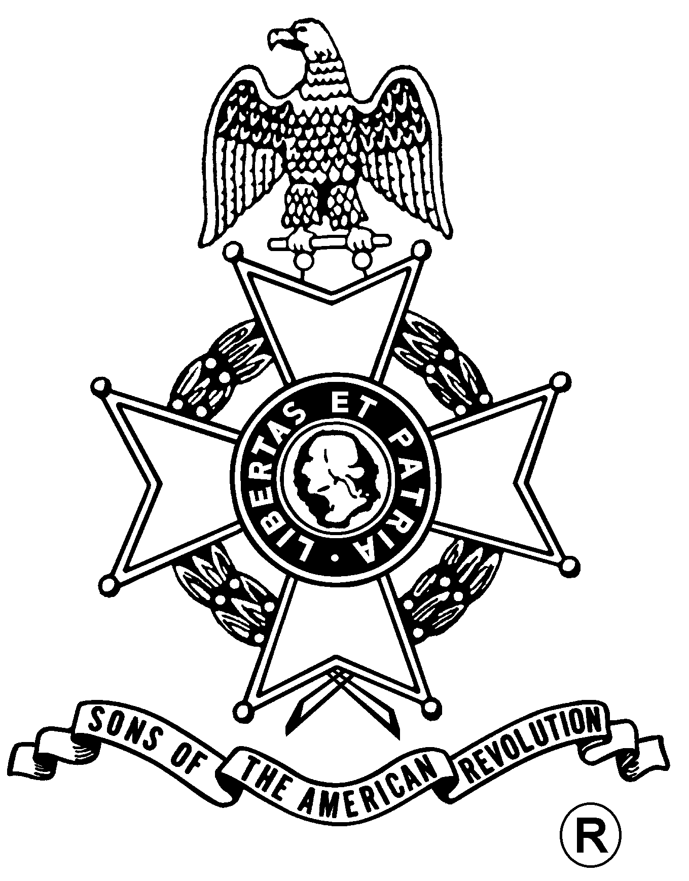
ANNUAL MEETING
And
WASHINGTON’S BIRTHDAY DINNER

Saturday, February 23, 2008
Manna’s Restaurant
17 Low Street, Ballston Spa, NY (518) 885-1195

Fellowship, 5:30 pm – $24.00 per Dinner, Served at 6:00 pm
(RSVP by February 17th)

Tossed Salad / Rolls & Butter
Choice of
Herb Stuffed Chicken, Roast Prime Rib, or Baked Scrod with Cracker Crust

Chef’s Choice Vegetable and Starch

Apple Pie & Coffee or Tea

Business Meeting
Award Presentations
- Speaker -
SNHP Ranger William Valosin
Early American Tinsmithing

Mail to: Michael Companion, Treasurer Telephone: (518) 885-5445
Saratoga Battle Chapter, SAR Email: Mscompanion@aol.com
121 W Milton Rd.
Ballston Spa, NY 12020-2805

Reservation Form: (Please, no email or phone reservations.)

Name: ___________________________________ Dinner Choice: ___________________

Name: ___________________________________ Dinner Choice: ___________________

Total Dinners @ $24 x ___ Dinners = $______ + Patriot Ancestor Listing Donation $________ = $________

Patriot Ancestor(s): _________________________________________________________
_________________________________________________________
_________________________________________________________

