SARATOGA BATTLE CHAPTER, NSSAR

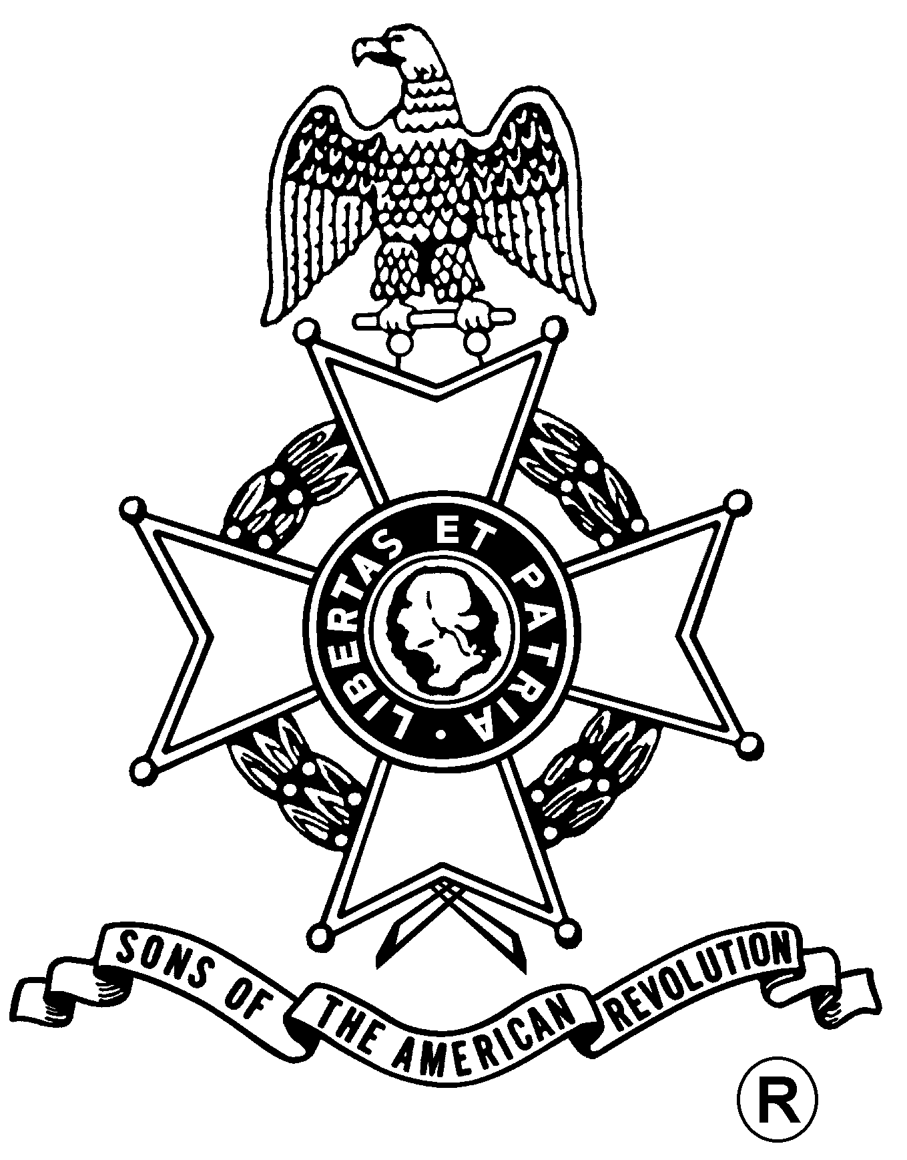
ANNUAL MEETING
And
WASHINGTON’S BIRTHDAY DINNER

Saturday, February 18, 2006
Century House Restaurant
997 New Loudon Rd (U.S. Rte 9), Latham, NY (518) 785-0931

Fellowship, 5:30 pm – $26.00 per Dinner, Served at 6:00 pm
(RSVP by February 11th)

Century House Salad
Choice of
Lemon Broiled Scrod (Bread Crumbs, Butter & Chardonnay)
Chicken Basilico (Pan-Seared Breast of Chicken with sun dried tomato basil cream sauce)
Sirloin Steak (Topped with roasted garlic and Cabernet demi-glace)

Chef’s Choice Vegetable and Starch

Homemade Biscuits & Strawberries with Whipped Cream

Business Meeting
Award Presentations
- Speaker -
Lieutenant Colonel Peter K. Goebel – Past Chapter President,
Current ESSSAR President, and NSSAR Color Guard Commander,
will speak on his experiences in Iraq.

Mail to: Richard H. Fullam, Treasurer Telephone: (518) 664-8910
Saratoga Battle Chapter, SAR Email: rfaero70@yahoo.com
14 Cabot Way
Clifton Park, NY 12065-2632

Reservation Form: (Please, no email or phone reservations.)

Name: ___________________________________ Dinner Choice: ___________________

Name: ___________________________________ Dinner Choice: ___________________

Total Dinners @ $26 x ___ Dinners = $______ + Patriot Ancestor Listing Donation $________ = $________

Patriot Ancestor(s): _________________________________________________________
_________________________________________________________
_________________________________________________________

