Reds Restaurant
12005 Route 9W - Coxsackie, NY 12051
Phone 518-731-8151

(From the South: NYS Thruway to Catskill Exit 21, take Rt. 23 east to Rt. 9W, go north 11 miles, on left)
(From the North: NYS Thruway to Exit 21B, take Rt. 9W south for 3 miles, on right))
Just north of Pegasus Restaurant

Motels available in Coxsackie, NY order online for better rates
Holiday Express - one tenth of a mile north off Exit 21B on 9W- Phone 518-719-1999
Best Western – two tenths of a mile south off Exit 21B on 9W- Phone 518-731-8100

ESSSAR BOM MEETING SATURDAY- November 6, 2021
Hosted by
Columbia-Mid Hudson Valley Chapter , SAR

COST OF BUFFET IS $25.00
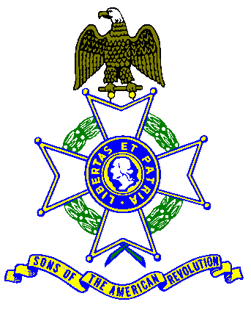 10:00 AM SIGN IN
COFFEE & DANISH until 11:00 AM

GENERAL MEETING 11:00 AM

Buffet Menu
Includes Coffee, Tea, Milk, Tax and Gratuity

Any wine, beer or alcohol drinks or extras, pay cash to the Server.
$5.00 EXTRA CHARGE AT DOOR FOR UNSCHEDULED ARRIVALS
FOR NON-EATING ATTENDEES - $5.00 CHARGE FOR USE OF FACILITY
---------------------------------------------------------------------------------------------------------------------------------------
Name __________________________________Chapter ____________________________________
Name __________________________________Chapter_____________________________________
Name ___________________________________Chapter ____________________________________
Buffet $25.00 ______ Using Facility only $5.00 ______
Detach, fill in names / chapter, make check payable to “CMHVSAR”.
Mail to: Richard Wambach, 232 Starbarrack Rd, Red Hook, NY 12571 - Please, no later Oct.28, 2021

