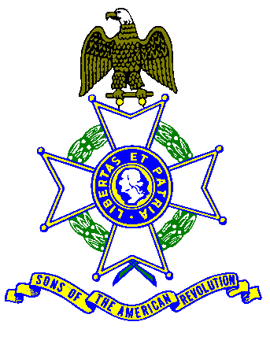
Empire State Society SAR
Board of Managers Meeting
March 24, 2018

To be held at the
Pegasus Restaurant
10885 Route 9W - Coxsackie, NY 12051
Phone 518-731-9200

(From the South: NYS Thruway to Catskill Exit 21, take Rt. 23 east to Rt. 9W, go north 8 miles, on left)
(From the North: NYS Thruway to Exit 21B, take Rt. 9W south for 5 miles, on right))

10:00am Sign In
11:00am General Meeting

COST OF BUFFET IS $22.00
Buffet Menu
Chicken Marsala
Roast Beef with Mashed Potatoes and Gravy
Beans, Tossed Green Salad, rolls & butter
Dessert - Apple Pie al a mode
Includes Coffee, Tea, Milk, Tax and Gratuity

$5.00 EXTRA CHARGE AT DOOR FOR UNSCHEDULED ARRIVALS
FOR NON-EATING ATTENDEES - $5.00 CHARGE FOR USE OF FACILITY
Motels available in Coxsackie, NY (Reserve online for better rates)
Holiday Express - one tenth of a mile north off Exit 21B on 9W- Phone 518-719-1999
Best Western – two tenths of a mile south off Exit 21B on 9W- Phone 518-731-8100

Name __________________________________Chapter_____________________________________
Name __________________________________Chapter_____________________________________
Name __________________________________Chapter_____________________________________
Buffet: #___ @ $22.00 = $______ Using Facility only: # ___ @ $5.00 = $______

Detach, fill in names, and write check to “Saratoga Battle Chapter SAR”
Mail to: David Flint, 89 Calvin Cole Rd, Stephentown, NY 12169-1800, email: davidflint@taconic.net
Please, no later than March 19, 2018

