Pegasus Restaurant
10885 Route 9W - Coxsackie, NY 12051
Phone 518-731-9200

(From the South: NYS Thruway to Catskill Exit 21, take Rt. 23 east to Rt. 9W, go north 8 miles, on left)
(From the North: NYS Thruway to Exit 21B, take Rt. 9W south for 5 miles, on right))

Motels available in Coxsackie, NY order on line for better rates
Holiday Express - one tenth of a mile north off Exit 21B on 9W- Phone 518-719-1999
Best Western – two tenths of a mile south off Exit 21B on 9W- Phone 518-731-8100

ESSSAR BOM MEETING SATURDAY- November 4, 2017
Hosted by
COLUMBIA-MID HUDSON VALLEY CHAPTER SAR (CMHVSAR)
www.cmhvsar.org

COST OF BUFFET IS $22.00
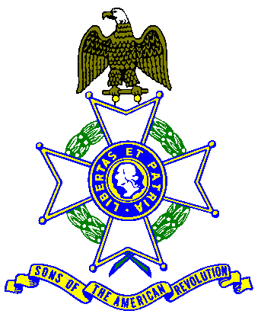 10:00 A M SIGN IN
COFFEE & DANISH until 11:00 AM

GENERAL MEETING 11:00 AM
Buffet Menu
Chicken Marsala
Roast Beef with Mashed Potatoes and Gravy
Beans, Tossed Green Salad, rolls & butter
Dessert- Apple Pie al a mode
Includes Coffee, Tea, Milk, Tax and Gratuity
Any wine, beer or alcohol drinks or extras, pay cash to the Server.
$5.00 EXTRA CHARGE AT DOOR FOR UNSCHEDULED ARRIVALS
FOR NON-EATING ATTENDEES - $5.00 CHARGE FOR USE OF FACILITY
---------------------------------------------------------------------------------------------------------------------------------------
Name __________________________________Chapter ____________________________________
Name __________________________________Chapter_____________________________________
Name ___________________________________Chapter ____________________________________
Buffet $22.00 ______ Using Facility only $5.00 _______
Detach, fill in names, and check to “CMHVSAR”
Richard Wambach - 232 Starbarrack Road, Red Hook, NY 12571-2252 - Please, no later Oct, 27, 2017

