EMPIRE STATE SOCIETY

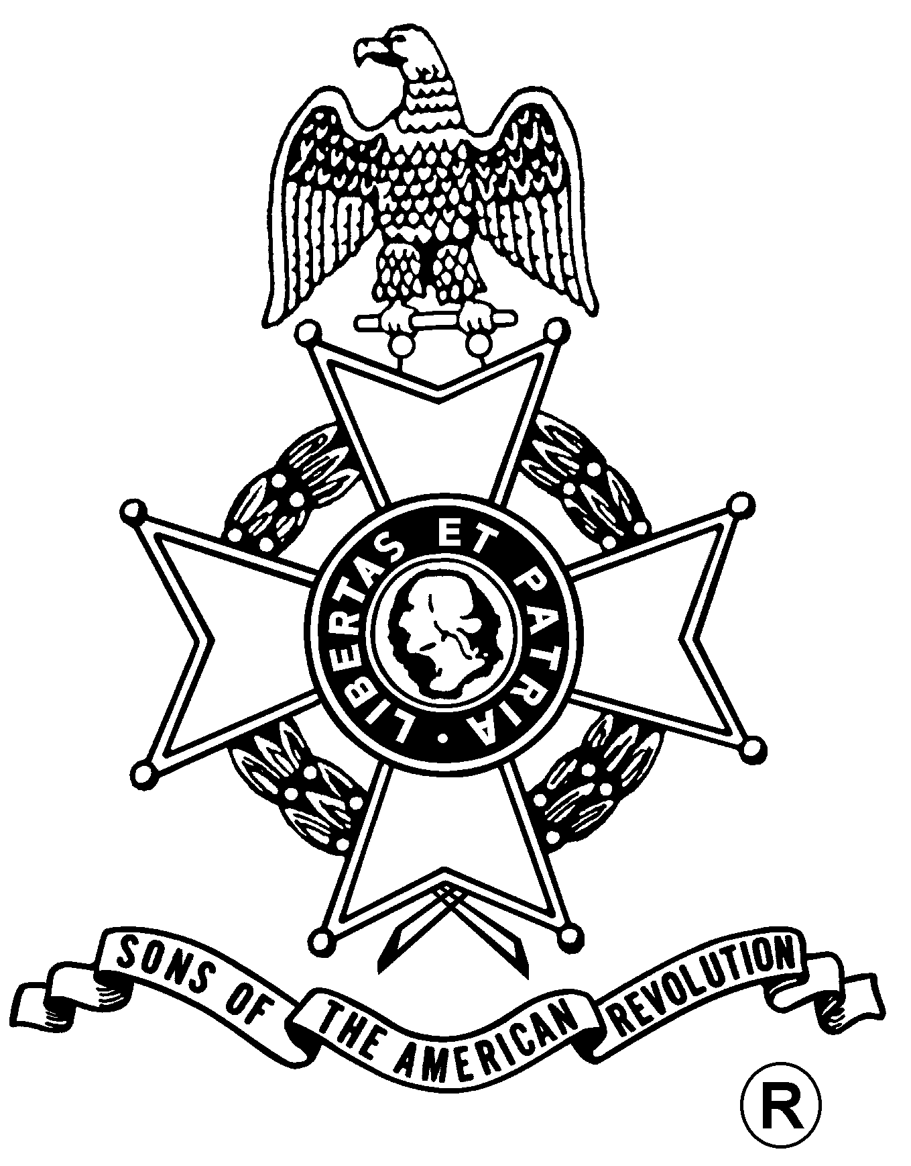
SONS OF THE AMERICAN REVOLUTION
BOARD OF MANAGERS MEETING

Hosted By
Saratoga Battle Chapter
Saturday, March 25, 2017

Pegasus Restaurant
10885 Route 9W – West Coxsackie, NY 12051
Phone 518-731-9200

COST OF BUFFET IS $21.00

Sign in & Coffee and Danish at 10 a.m.
Meeting at 11 a.m.

Lunch Menu Buffet Style
Beef Barley Soup
Chicken Marsala
Roast Beef with Mashed Potatoes and Gravy
Beans, Tossed Green Salad, rolls & butter
Dessert- Apple Pie al a mode
Includes Coffee, Tea, Milk, Tax and Gratuity
Any wine, beer or alcohol drinks or extras, pay cash to the Server.

$5.00 EXTRA CHARGE AT DOOR FOR UNSCHEDULED ARRIVALS
FOR NON-EATING ATTENDEES - $5.00 CHARGE FOR USE OF FACILITY

RSVP by March 21
with check payable to the Saratoga Battle Chapter SAR

Mail To:
Mail to: David Flint, Treasurer Telephone: (518) 733-5871
Saratoga Battle Chapter, NSSAR Email: treasurer@saratogabattle-sar.org
89 Calvin Cole Road.
Stephentown, New York 12168

Directions

(From the South: NYS Thruway to Catskill Exit 21, take Rt. 23 east to Rt. 9W, go north 8 miles, on left)
(From the North: NYS Thruway to Exit 21B, take Rt. 9W south for 5 miles, on right))

Lodging
At the Coxsackie Exit 21B: Best Western (518-731-8100); Red Carpet Inn (518-731-2722)

(RSVP by March 21)

Reservation Form:

Name: ___________________________________ Choice ($) __________ Non-Dining ($5): _______

Name: ___________________________________ Choice ($) __________ Non-Dining ($5): _______

