EMPIRE STATE SOCIETY

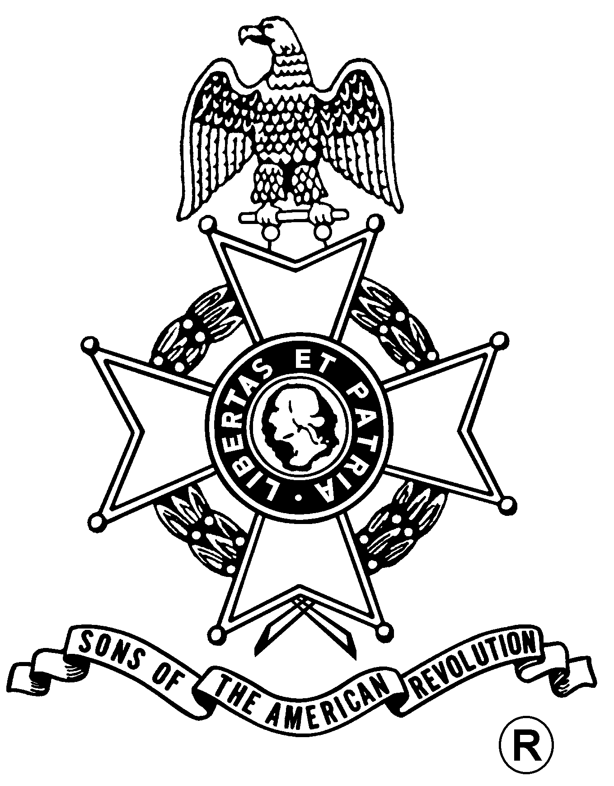
SONS OF THE AMERICAN REVOLUTION
BOARD OF MANAGERS MEETING

Hosted By
Columbia-Mid Hudson Valley Chapter
Saturday, March 23, 2013

The Beekman Arms & Delamater Inn
(Wayfarer Room)
6387 Mill St
Rhinebeck, NY 12572
(845) 876-1766

Coffee, Tea & Water from 10 – 11 am; Meeting at 11 am

- Deli Style Lunch Menu -
Sliced Fruit Platter; Deli Sandwich Platter of Roasted & Sliced Turkey,
Roast Beef & Curried Chicken Salad; Penne Pasta with a Marinara Sauce; Potato Salad;
Tavern Cole Slaw; Field Green Salad; Chef’s Choice Dessert; Coffee/Tea/Soda

Total Price $24.00; $5.00 Non-Dining Charge

RSVP by March 13
with check payable to the Columbia-Mid Hudson Valley Chapter, SAR

Mail To:
Richard Wambach, 232 Starbarrack Rd, Red Hook, NY 12571-2252

Telephone: (845) 758-5568 Email: richardlw47@gmail.com

Directions

Via New York State Thruway (#87): Exit 19 (Kingston/Rhinecliff Bridge). Follow signs to Rhinecliff Bridge. Go over bridge to the 2nd traffic light. Make right at light onto 9G South. Go to 1st traffic light. Make right at light onto 9 South. Go approximately 2 miles to Inn, on right at traffic light in Rhinebeck.
- OR -
Visit the ESS Website At:
http://www.ess-sar.org/
For Door to Door Directions

(RSVP by March 13)

Reservation Form:

Name: ___________________________________ ($24) ____________ Non-Dining ($5): _______

Name: ___________________________________ ($24) ____________ Non-Dining ($5): _______

