EMPIRE STATE SOCIETY

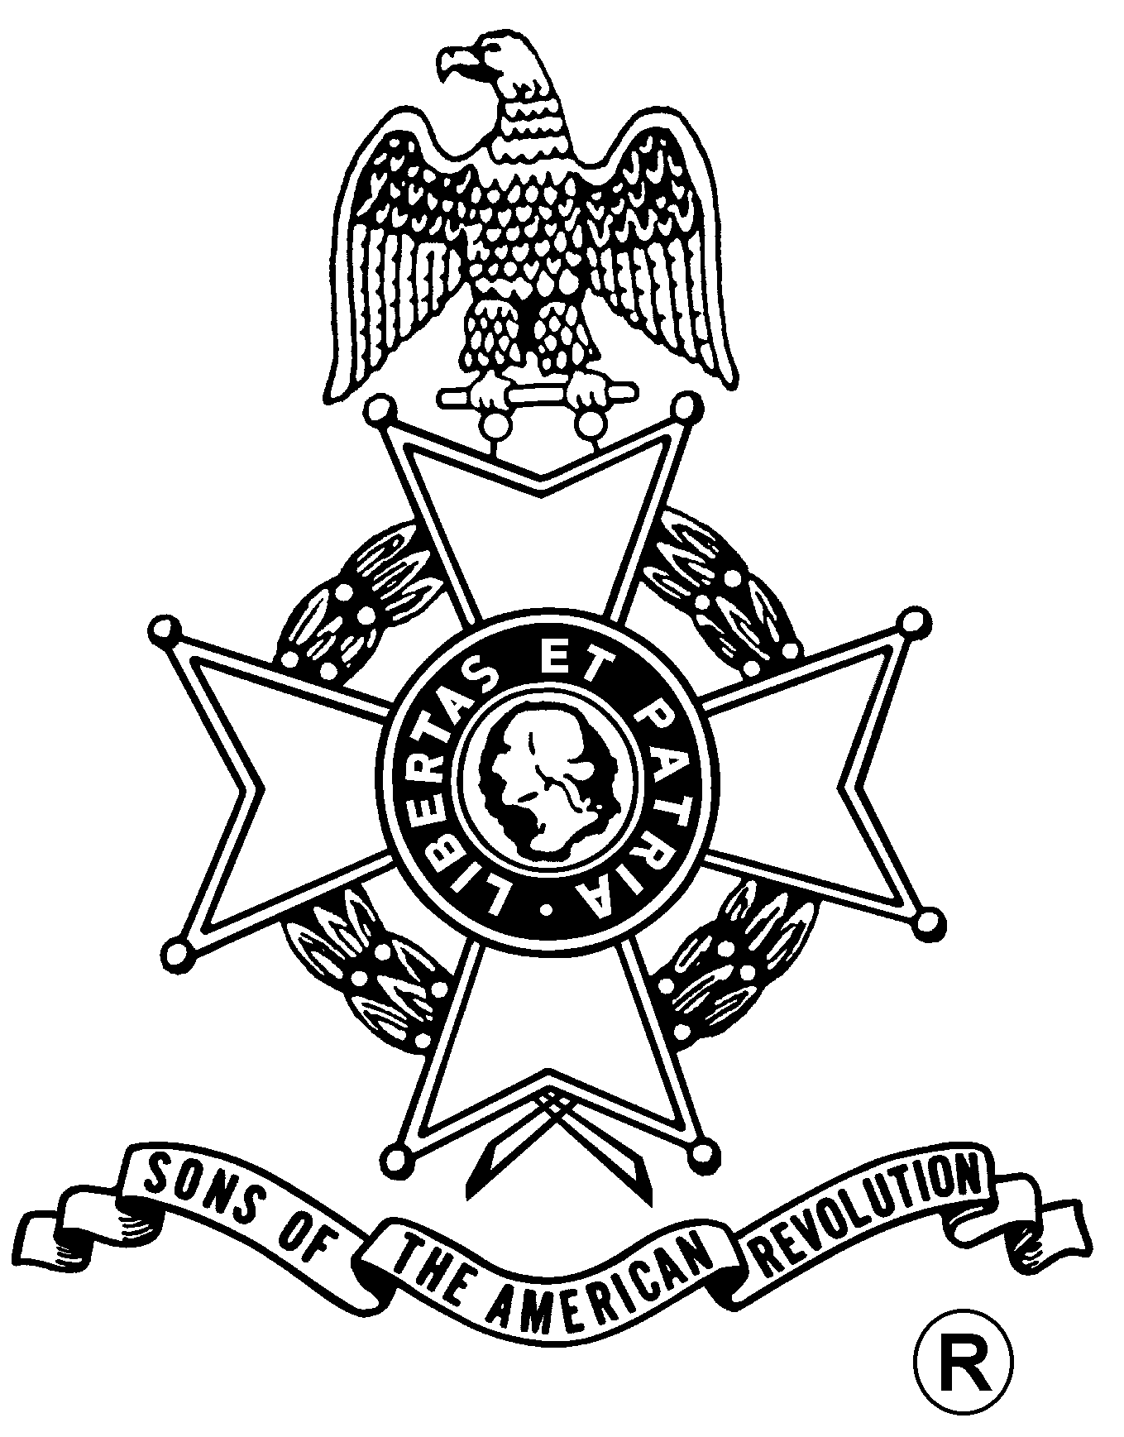
SONS OF THE AMERICAN REVOLUTION
BOARD OF MANAGERS MEETING

Hosted By
Schoharie-Leatherstocking Chapter
Saturday, November 23, 2013

The Old Stone Fort*
145 Fort Rd
Schoharie, NY 12157
(518) 295-7192
* Tours available to Members for $5 each

Coffee, Tea & Water from 10 – 11 am; Meeting at 11 am

Baked Ziti, Hawaiian Chicken with vegetables over rice, Salad, Italian Bread & Dessert
Total Price $24.00; $29.00 at the Door; $5.00 Non-Dining Charge

RSVP by November 13
With check payable to: Schoharie L-S Chapter, SAR

Mail To:
Mr. Bryan Braun, 72 Duncan Phyfe Ln, Slingerlands, NY 12159-9378

Telephone: (518) 475-9780 Email: karnbry@hotmail.com

Directions
From the west: Exit 27 to NY Route 30 South to Village of Schoharie
From the South or North I-87 to Albany; I-90 (NYS Thruway) West to Exit 25A (I-88) West
to Exit#23 NY Route 30 South to Village of Schoharie
Follow markers to Old Stone Fort
- OR -
Visit the ESS Website At:
http://www.ess-sar.org/
For Door to Door Directions
Accommodations:
Days Inn: 160 Holiday Way (Right off of NY 30 South between Mobil Station & Dunkin Donuts)
Ask for Veterans Discount
(518) 295-6088 or (800) 992 2694 (National Reservation #)

(RSVP by November 13)

Reservation Form:

Name: ___________________________________ ($24) ____________ Non-Dining ($5): _______

Name: ___________________________________ ($24) ____________ Non-Dining ($5): _______

