EMPIRE STATE SOCIETY

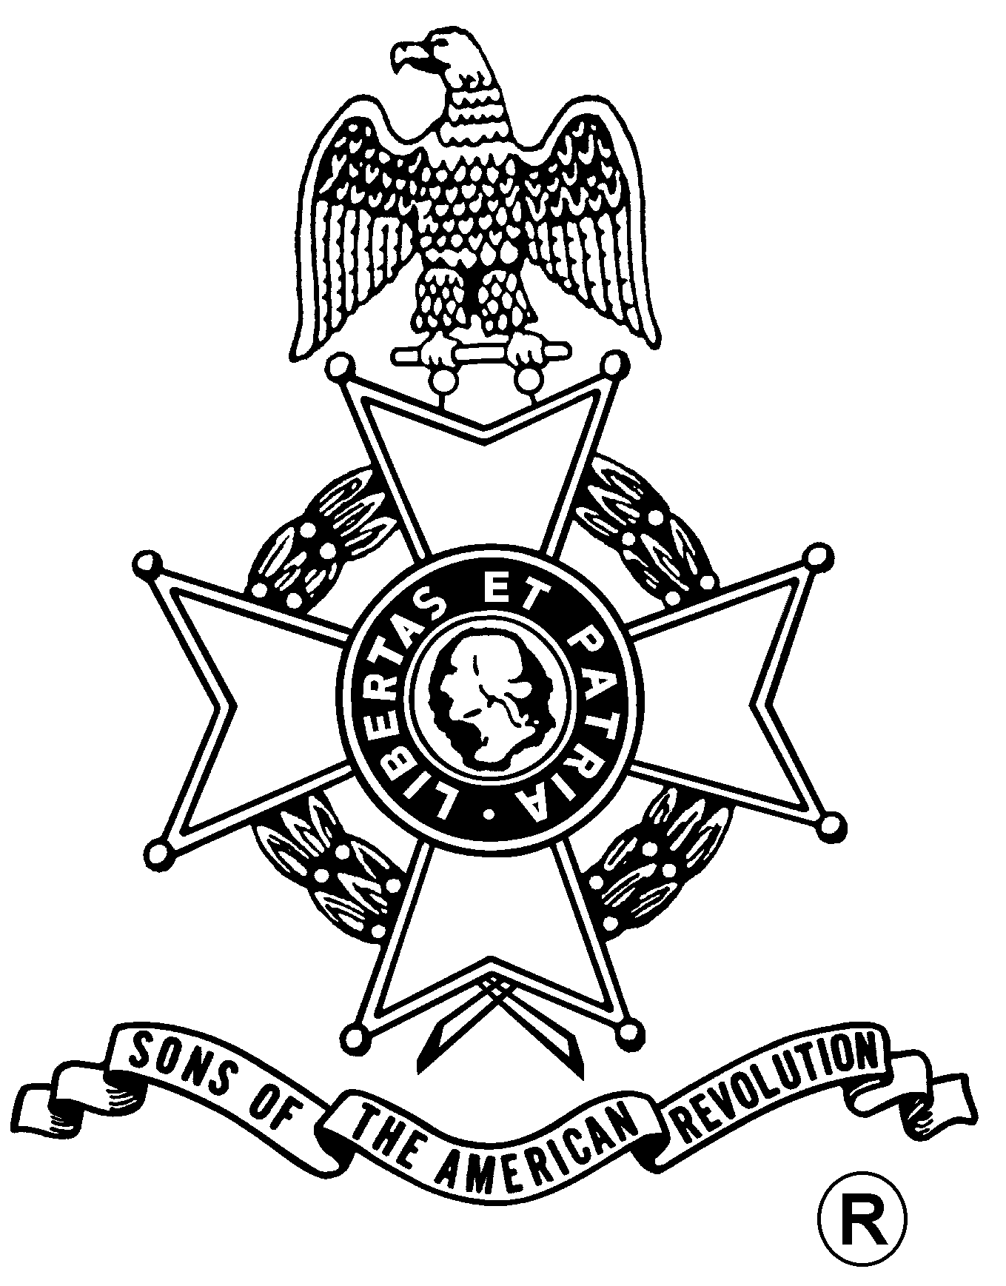
SONS OF THE AMERICAN REVOLUTION
BOARD OF MANAGERS MEETING

Hosted By
Saratoga Battle Chapter
Saturday, March 19, 2011

Gloversville / Johnstown Holiday Inn
308 North Comrie Ave, Johnstown, NY 12095
(518) 762-4686

Coffee and Danish at 10 a.m., Meeting at 11 a.m.

Lunch Menu
Tossed Green Salad, Rolls and Butter, Sliced Roast Beef, Sliced Turkey, Sliced Salami, Cole Slaw, Penne Pasta, Meatballs, Fresh Fruit Salad, Coffee/Tea/Soda, Cherry Cobbler

Total Price $23.00; $5.00 Non-Dining Charge

RSVP by March 13
with check payable to the Saratoga Battle Chapter SAR

mailed to
Richard Fullam, Past Pres., Saratoga Battle Chapter, SAR, 14 Cabot Way, Clifton Park, NY 12065 E-mail: rfaero70@yahoo.com

Directions

From the NYS Thruway to Fultonville Exit 28, west on Riverside Drive, follow NY-30A 6.6 miles. Holiday Inn on the right

Lodging
At the Johnstown / Gloversville Holiday Inn: (518) 762-4686

(RSVP by March 13)

Reservation Form:

Name: ___________________________________ Lunch ($23) __________ Non-Dining ($5): _______

Name: ___________________________________ Lunch ($23) __________ Non-Dining ($5): _______

