EMPIRE STATE SOCIETY

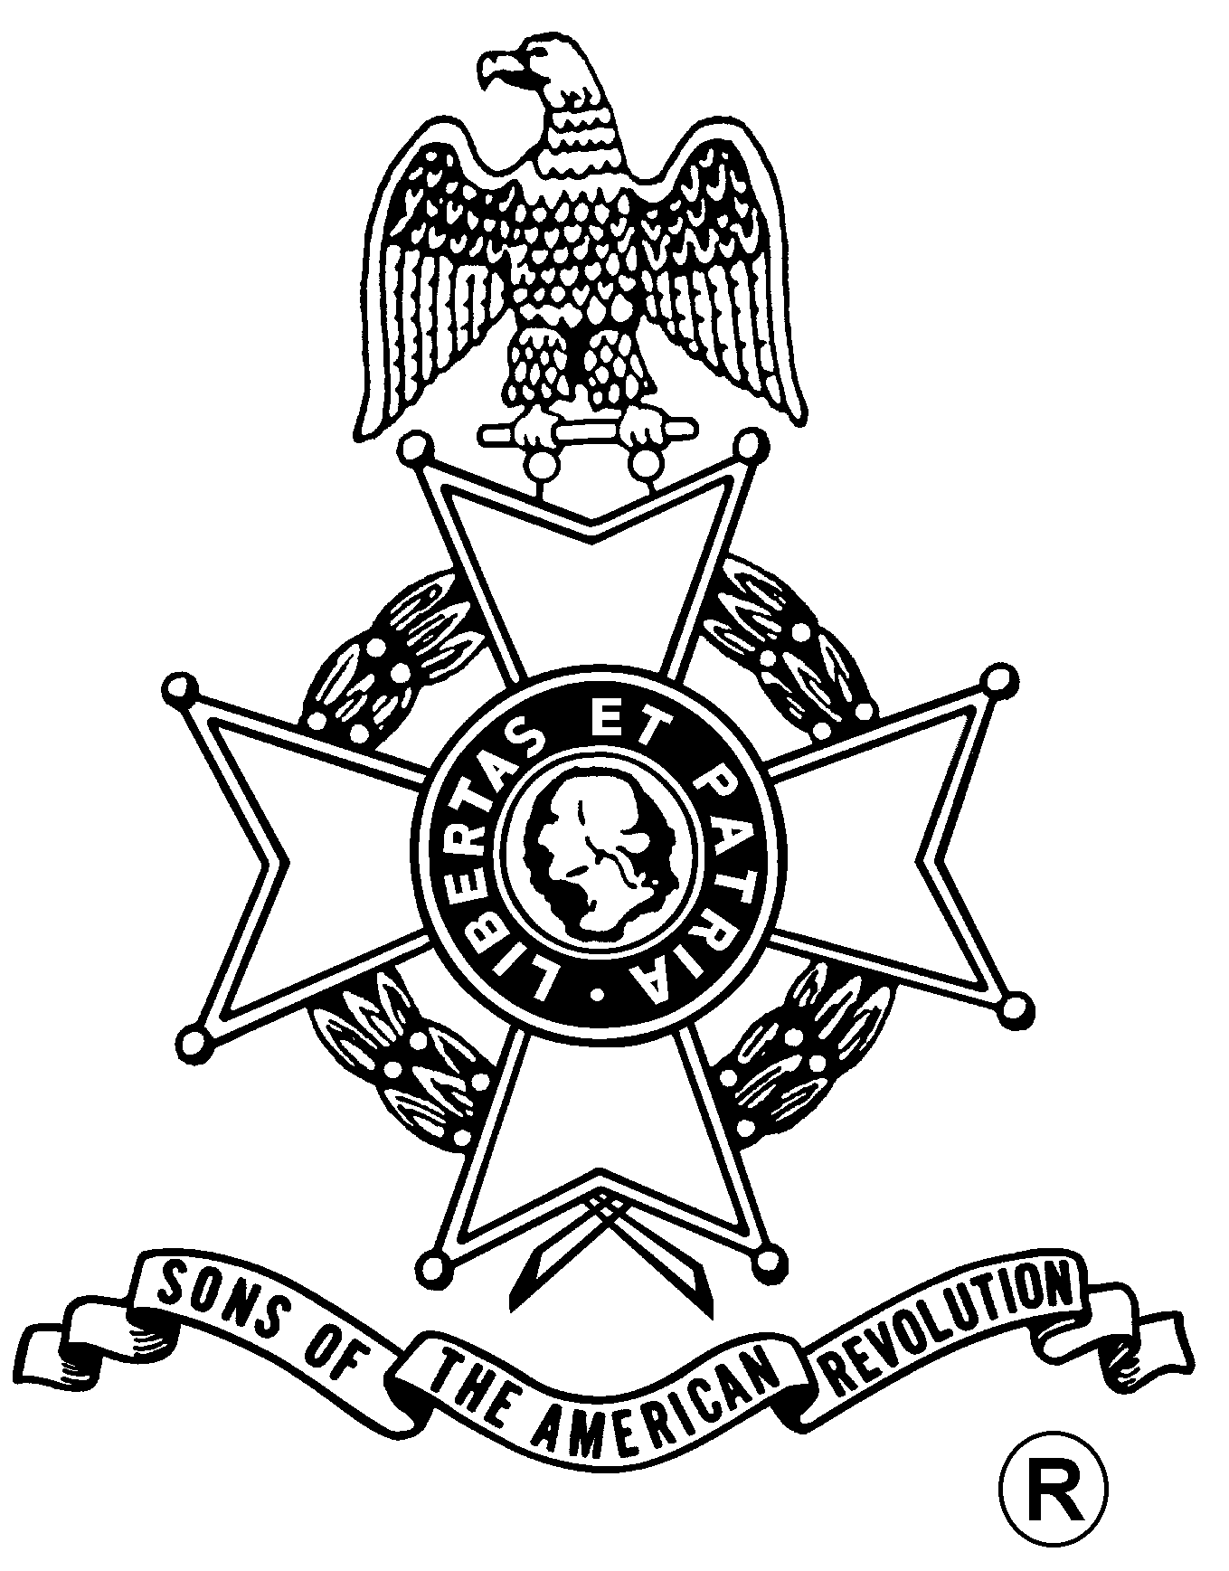
SONS OF THE AMERICAN REVOLUTION
BOARD OF MANAGERS MEETING

Hosted By
Stone Arabia Chapter
And
Saratoga Battle Chapter
Saturday, March 13, 2010

Gloversville / Johnstown Holiday Inn
308 North Comrie Ave, Johnstown, NY 12095
(518) 762-4686

Coffee and Danish at 10 a.m., Meeting at 11 a.m.

Lunch Menu
Tossed Green Salad, Rolls and Butter, Sliced Roast Beef, Sliced Turkey, Sliced Salami, Cole Slaw, Penne Pasta, Meatballs, Fresh Fruit Salad, Coffee/Tea/Soda, Cherry Cobbler

Total Price $15.00; $5.00 Non-Dining Charge

RSVP by March 6
with check payable to the Stone Arabia Chapter SAR

mailed to
John Frederick, Pres., Stone Arabia Chapter, SAR, 38 Highland Terrace, Gloversville, NY 12078 Telephone: (518) 725-5102
Richard Fullam, Pres., Saratoga Battle Chapter, SAR, E-mail: rfaero70@yahoo.com

Directions

From the NYS Thruway to Fultonville Exit 28, west on Riverside Drive, follow NY-30A 6.6 miles. Holiday Inn on the right

Lodging
At the Johnstown / Gloversville Holiday Inn: (518) 762-4686

(RSVP by March 6)

Reservation Form:

Name: ___________________________________ Lunch ($15) __________ Non-Dining ($5): _______

Name: ___________________________________ Lunch ($15) __________ Non-Dining ($5): _______

