Empire State Society
Sons of the American Revolution
2010 Annual meeting

Hosted By
Fingerlakes Chapter, SAR
Saturday, May 15, 2010

Ramada Ithaca Executive Conference Center
2310 N Triphammer Rd
Hwy 13 & Triphammer Rd
Ithaca, NY, 14850 US
Phone: 607-257-3100
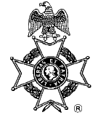
Social Gathering at 10 a.m. Meeting at 11a.m

Lunch Menu
Sliced Turkey Breast W/Country Stuffing, Cranberry sauce
Mashed Potatoes W/Turkey Gravy, Buttered Sweet Corn W/Red Peppers
Marinated Grilled Vegetables, Fresh Fruit Salad
Garden Salad W/Ranch & Italian Dressing, Rolls W/Butter
Assorted Dessert Pastry Platter- 1 per table
Coffee, Decaf Coffee, Hot Tea, Ice Tea
Total price $14.25 includes tax and gratuity --$5.00 non dining charge
Walk-ins may not get the reserved price

RSVP by May 1, 2010
Check payable to the Fingerlakes Chapter, SAR

Mailed to:
Ronald Schmitt, Treasurer, Fingerlakes Chapter, SAR
302 E. Upland Road, Ithaca, NY 14850

Lodging
Rooms may be available at the Ramada Inn-Call the Ramada for reservations
Free transportation (with overnight reservations) from the Ithaca/Tompkins County Airport-Call the Ramada.

Detailed directions on the reverse
-------------------------------------------------------------------------------------
Reservations Required by May 1, 2010

Name ______________________________________________________________
Name _____________________________________Amount Enclosed __________

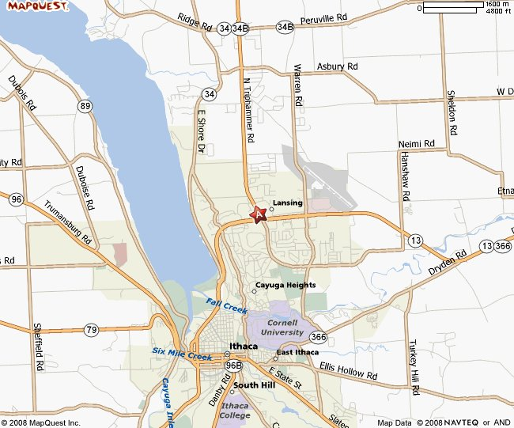
Ramada Ithaca Executive Conference Center
2310 N Triphammer Rd
Hwy 13 & Triphammer Rd
Ithaca, NY 14850 US
Phone: 607-257-3100 Fax: 607-257-4425

From North:
Interstate 81 South to Exit 12. Turn left onto US Route 281 South continue to Route 13 South to Ithaca. Turn right onto Triphammer Road, Ramada will be on the left in .25 mile.

From South:
Interstate 81 North to Exit 8. Follow Route 79 West into Ithaca. Turn right onto Route 13 North. Turn left onto Triphammer Road, Ramada will be on the left in .25 mile.

From East:
NY State Thruway/I-90 West to Exit 34A. Follow Interstate 481 South to Interstate 81 South to Exit 12. Turn left onto US Route 281 South continue to Route 13 South toward Ithaca. Turn right onto Triphammer Road, Ramada will be on the left in .25 mile.

From West:
NY State Thruway/I-90 West to Exit 41. Route 318 East to Route 89 South into Ithaca to Route 13 North. Turn left onto Triphammer Road, Ramada will be on the left in .25 mile.

From Tompkins County Regional Airport:
Route 13 South to the Triphammer Road/Pyramid Mall Exit. Turn right onto Triphammer Road, Ramada will be on the left in .25 mile (Free Transportation from the airport to the Ramada- Call Ramada)

