EMPIRE STATE SOCIETY
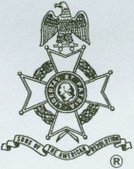
SONS OF THE AMERICAN REVOLUTION
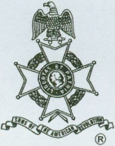
ANNUAL MEETING
Hosted By
Saratoga Battle Chapter Saturday, May 10, 2008
Pegasus Restaurant
10885 Route 9W, Coxsackie, NY 12051 (518)731-9200
Coffee and Danish at 10 am; Meeting at 11 am
Lunch Menu
Tossed Green Salad, Cream of Chicken Soup, Roast Beef with Mashed Potatoes and Gravy, Chicken Marsala, Mixed Vegetables, Rolls and Butter, Apple Pie al a mode, Coffee/Tea/Milk
Total Price $20.00; $5.00 Non-Dining Charge
RSVP by May 5
Make check payable to the Saratoga Battle Chapter, SAR
Mail to: Richard H. Fullam, First VP, Saratoga Battle Chapter, SAR, 14 Cabot Way, Clifton Park, NY 12065-2632
Telephone: (518) 664-8910 Email: rfaero70@yahoo.com
Directions
From the South: NYS Thruway to Catskill Exit 21, Route 23 east to Route 9W north 8 miles.
From the North: NYS Thruway to Coxsackie Exit 2IB, Route 9W south 5 miles.
Or Visit Our Website At
http://www.saratogabattle-sar.org/
For Door to Door Directions
Lodging
At the Coxsackie Exit 2IB: Best Western (518) 731-8100; Red Carpet Inn (518) 731-2722
________________________________________________________________________________________________________

(RSVP by May 5)
Reservation Form:
Name: ________________________ ______ Lunch ($20): ______________Non-Dining ($5): _____________
Name: ________________________ ______ Lunch ($20):______________Non-Dining ($5): _____________

