SARATOGA CHAPTER, NSDAR

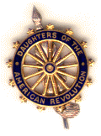
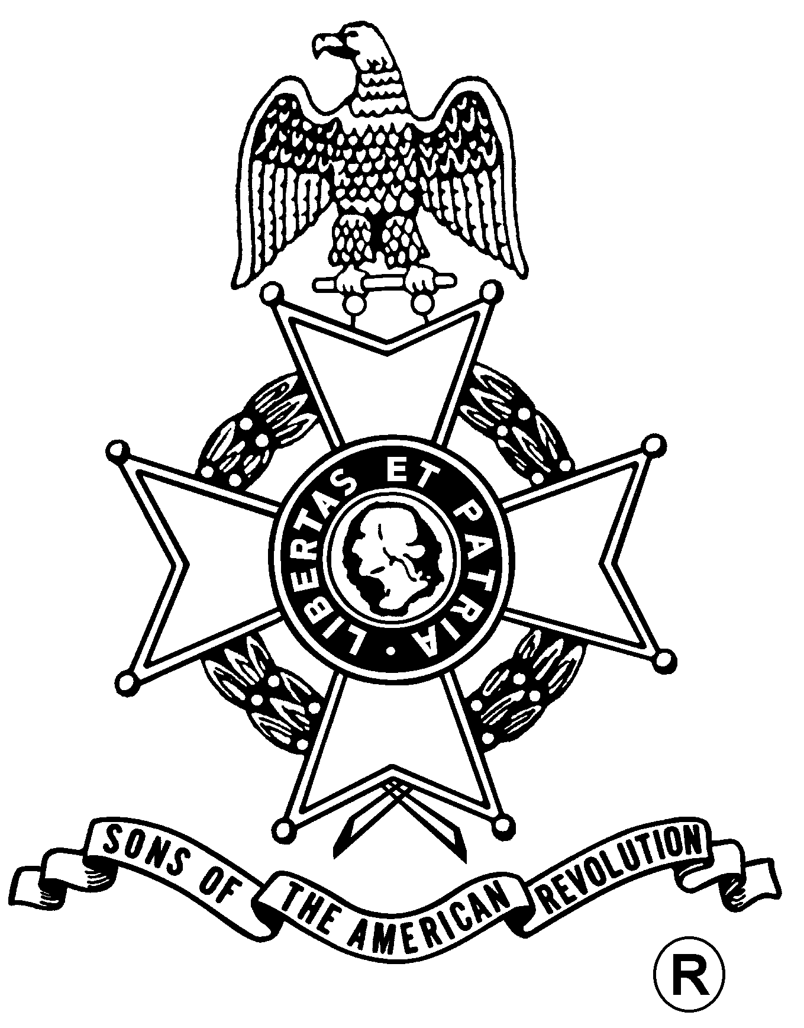
SARATOGA BATTLE CHAPTER, NSSAR
ANNUAL WREATH LAYING

Sunday, September 17, 2006
®
Wreath Laying Ceremony, 2:00pm
DAR Monument, Stop #2 on Tour Road
Saratoga National Historical Park, Stillwater, NY (518) 664-9821

Fellowship - 4:30 pm – $26.00 per Dinner - 5:30 pm
Ecobelli's Restaurant (see reverse)
1475 Saratoga Road (NY Route 50), Ballston Spa, NY 12020 (518) 885-5900
(RSVP by Sept. 12)

One hour of Hors D’oeuvres
Baby Greens Salad / Bread & Butter
Choice of
Stuffed Chicken Breast, 12oz.Slow cooked Prime Rib with Au Jus, or Scrod Franciase
Potatoes or Rice & Vegetable
Dessert & Coffee, Tea, & Soda

Saratoga Battle Chapter, NSSAR Meeting, Immediately After Ceremony
SNHP Visitor’s Center Meeting Room

Reservation Form: (Please, no email or phone reservations.)

Will attend the ceremony at 2:00 pm - # Attending _____

Will attend Saratoga Battle Chapter, NSSAR Meeting - # Attending ______

Will attend Dinner at 5:30 pm (No cancellations after 12 Sept.)

Name: ___________________________________ Dinner Choice: ___________________

Name: ___________________________________ Dinner Choice: ___________________

Total Dinners @ $26.00 x ___ Dinners = $________ + Donation $________ = $________

Mail to: Richard H. Fullam, Treasurer Telephone: (518) 664-8910
Saratoga Battle Chapter, NSSAR Email: rfaero70@yahoo.com
14 Cabot Way
Clifton Park, NY 12065-2632
Directions
from
Saratoga National Historical Park
to
Ecobelli's Restaurant

from to

Saratoga Battlefield Ecobelli's Restaurant
648 Route 32 1475 Saratoga Road
Stillwater, NY 12170-1604 Ballston Spa, NY 12020
(518) 664-9821 (518) 885-5900

approximate distance: 14 miles approximate driving time: 25-30 minutes

1. Use Route 32 Exit to leave Park

2. Left onto NY Route 32 (south) @ 1.2 miles

2. Right onto NY 423 (west) @3.9 miles

4. Turn Left onto NY 9P (one Stop Sign on Route 9P) @ 4.1 mile

6. Cross US Route 9 onto East High St (toward Ballston Spa) @ 3.3 miles

7. Left on Route 50 @ 1.5 mile

9. Arrive at Ecobelli's (on right, across from Mangino’s Pontiac)

