EMPIRE STATE SOCIETY

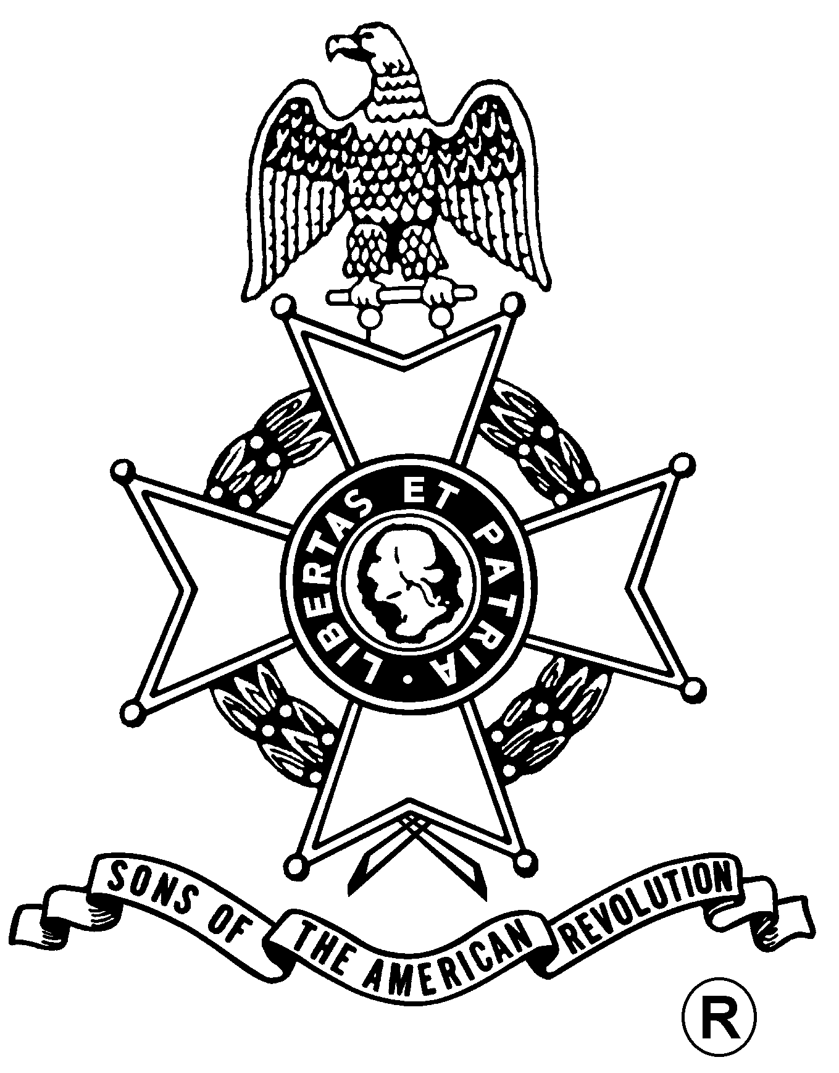
SONS OF THE AMERICAN REVOLUTION
BOARD OF MANAGERS MEETING

Hosted By
Saratoga Battle Chapter
Saturday, March 25, 2006

Pegasus Restaurant
10885 Route 9W, Coxsackie, NY 12051
(518) 731-9200

Coffee and Danish at 10 a.m., Meeting at 11 a.m.

Lunch Menu
Tossed Green Salad, Rolls and Butter, Chicken Marsala, Baked Scrod,
Roast Beef with Mashed Potatoes and Gravy, Beans, Apple Pie al a mode, Coffee/Tea/Milk

Total Price $18.00; $5.00 Non-Dining Charge

RSVP by March 18
with check payable to the Saratoga Battle Chapter SAR
Mail to:
Richard H. Fullam, Treasurer, Saratoga Battle Chapter, SAR, 14 Cabot Way, Clifton Park, NY 12065-2632 Telephone: (518) 664-8910 Email: rfaero70@yahoo.com

Directions:

From the South: NYS Thruway to Catskill Exit 21, Route 23 east to Route 9W north 8 miles.

From the North: NYS Thruway to Coxsackie Exit 21B, Route 9W south 5 miles.

Or Visit Our Website At
http://www.saratogabattle-sar.org/
For Door to Door Directions
Lodging:
At the Coxsackie Exit 21B: Best Western (518-731-8100); Red Carpet Inn (518-731-2722)

(RSVP by March 18)

Reservation Form:

Name: ___________________________________ Lunch ($18) __________ Non-Dining ($5): _______

Name: ___________________________________ Lunch ($18) __________ Non-Dining ($5): _______

