EMPIRE STATE SOCIETY

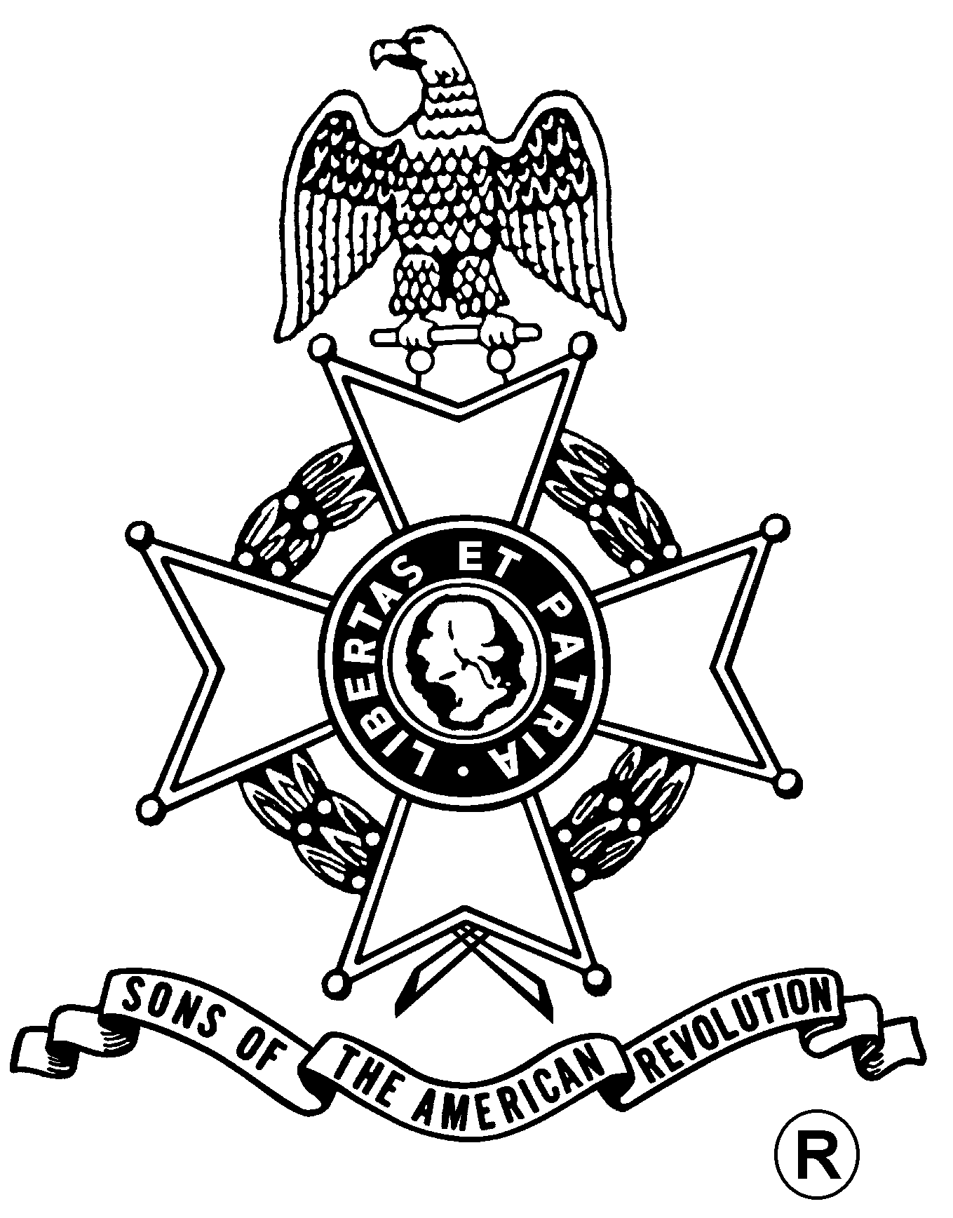
SONS OF THE AMERICAN REVOLUTION
BOARD OF MANAGERS MEETING

Hosted By
Walloomsac Battle Chapter
Saturday, September 23, 2006

Pegasus Restaurant
10885 Route 9W, Coxsackie, NY 12051
(518) 731-9200

Coffee and Danish at 10 a.m., Meeting at 11 a.m.

Lunch Menu
Tossed Green Salad, Rolls and Butter, Chicken Marsala, Baked Scrod,
Roast Beef with Mashed Potatoes and Gravy, Beans, Apple Pie al a mode, Coffee/Tea/Milk

Total Price $18.00; $5.00 Non-Dining Charge

RSVP by September 16
with check payable to the Walloomsac Battle Chapter SAR

mailed to
Duane Booth, Treasurer, Walloomsac Battle Chapter
SAR, P.O. Box 836, New Lebanon, NY 12125-0836

Telephone: (518) 733-0830 Email: boots42@taconic.net

Directions
From the South: NYS Thruway to Catskill Exit 21, Route 23 east to Route 9W north 8 miles.
From the North: NYS Thruway to Coxsackie Exit 21B, Route 9W south 5 miles.

Or Visit the Saratoga Battle Website At
http://www.saratogabattle-sar.org/
For Door to Door Directions
Lodging
At the Coxsackie Exit 21B: Best Western (518-731-8100); Red Carpet Inn (518-731-2722)

(RSVP by September 16)

Reservation Form:

Name: ___________________________________ Lunch ($18) __________ Non-Dining ($5): _______

Name: ___________________________________ Lunch ($18) __________ Non-Dining ($5): _______

