EMPIRE STATE SOCIETY

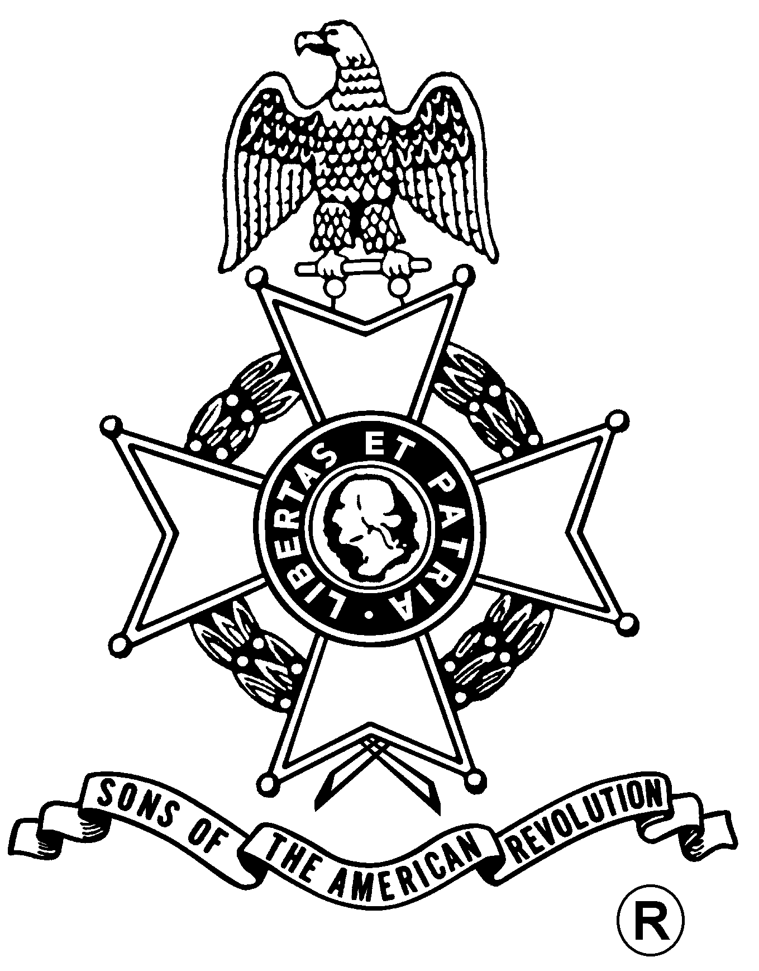
SONS OF THE AMERICAN REVOLUTION

BOARD OF MANAGERS MEETING

Hosted By
Syracuse Chapter
Saturday, November 18, 2006

Wyndham Syracuse Hotel
6301 Route 298, East Syracuse, NY 13057
(315) 432-0200

Meeting at 11 a.m.

Lunch Menu
Harvest Garden Salad, Rolls and Butter
London Broil or Italian Chicken
Starch and Vegetable, NY Apple Strudel, Coffee or Tea

Total Price $20.00; $5.00 Non-Dining Charge
RSVP by November 13
with check payable to the Syracuse Chapter, SAR

mailed to
Tom Henry, Treasurer, Syracuse Chapter, SAR, 103 Kline Road, Pennellville, NY 13132

Lodging
$125.00 per night or others in the area

(RSVP by November 13)

Reservation Form:

Name: __________________________________Beef___ Chicken___ Lunch ($20) ___ Non-Dining ($5): ___

Name: __________________________________ Beef___ Chicken___ Lunch ($20) ___ Non-Dining ($5): ___

