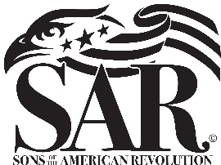
SARATOGA BATTLE CHAPTER
Sons of the American Revolution
Please Join Us for Our Biannual Dinner Meeting following the Saratoga Battlefield Wreath Presentation Sunday, September 18.
Details: At 2 p.m. we’ll meet with regional representatives of the Daughters of the American Revolution at the Monument at Stop #2 on the Tour Road of Saratoga National Historical Park, Stillwater, NY. There, we will pay our respects to our Patriot Ancestors by presenting wreaths at the DAR Monument.
At 4 p.m. we will begin fellowship with drinks at the Clifton Park VFW Post 1498 at 1605 US Route 9, Clifton Park, NY 12065. The meeting and dinner will follow.
We’ll have a buffet style meal featuring the following: Tossed salad, Sausage & Peppers, Ziti, Chicken Marsala and Bourbon Tips. We’ll have coffee, water, soft drinks and other beverages and possibly cookies for dessert.
Cost: $28 per-person

Name | Number Attending | Total at $28 each | Donation In Honor of Patriot Ancestor (s)
Total submitted:
Patriot Ancestor(s) Name:

Mail to: David L. Flint, Treasurer. 89 Calvin Cole Road, Stephentown, NY 12169-1800 | (518) 733-5871 | treasurer@saratogabattle-sar.org

